Determination of the viscoelastic properties of a single cell cultured on a rigid support by force microscopy

Pablo D. Garcia and Ricardo Garcia*
Materials Science Factory
Instituto de Ciencia de Materiales de Madrid, CSIC
c/ Sor Juana Ines de la Cruz 3
28049 Madrid, Spain
Email address: r.garcia@csic.es

ABSTRACT

Understanding the relationship between the mechanical properties of living cells and physiology is a central issue in mechanobiology. Mechanical properties are used as fingerprints of the pathological state of a single cell. The force exerted on a cell is influenced by the stiffness of the solid support needed to culture it. This effect is a consequence of the cell’s boundary conditions. It causes a cell to appear with mechanical properties different from their real values. Here we develop a bottom effect viscoelastic theory to determine the viscoelastic response of a cell. The theory transforms a force-distance curve into the cell’s Young’s modulus, loss modulus, relaxation time or viscosity coefficient with independence of the stiffness of the rigid support. The theory predicts that, for a given indentation, the force exerted on the cell’s periphery will be larger than on a perinuclear region. Results based on the use of semi-infinite contact mechanics models introduce large numerical errors in the determination of the mechanical properties. Finite element simulations confirm the theory and define its range of applicability.

KEYWORDS
Force spectroscopy, cell nanomechanics, nanorheology, viscoelastic theory, atomic force microscopy, force distance curves

The atomic force microscope (AFM) is widely used to measure the mechanical response of soft matter including polymers¹⁻⁶, proteins⁷⁻¹³, virus capsides¹⁴⁻¹⁵, cells¹⁶⁻²⁴ and tissues²⁵. In fact, Young’s moduli values obtained from AFM indentation experiments have been correlated with the physiological and/or pathological state of a cell²⁶⁻²⁸. The experimental procedure requires the deposition, adsorption or culture of the specimen on a solid rigid support. The Young’ moduli of the most common sample supports for AFM imaging (mica, glass or silicon) are in the 50-170 GPa range. Those values are several orders of magnitude larger than the values of some soft matter systems such as single proteins (10-90 MPa), membrane proteins (~50 MPa), gels or mammalian cells (10²-10⁴ Pa). In some cases, the force applied by the AFM probe could produce deformations comparable to the cell’s thickness, in particular, if the measurements are performed far from the nucleus.
Numerical simulations show that for a material characterized by a Young’s modulus of 1 kPa, the application of 1 nN would produce an indentation of about 500 nm²⁹. Large indentations on thin and soft materials could propagate the stress exerted by the probe to the cell-solid support interface. This bottom effect would affect the force-distance curve measurements by providing higher repulsive forces which would lead to report higher apparent Young’ modulus values. Some contributions have addressed this artefact by introducing the so-called bottom effect corrections for flat punch, spherical and conical probes³⁰⁻³¹. Those corrections enable to recover from the force-distance curves the true Young’s modulus of a cell. However, the above corrections have been deduced by assuming that the cell behaves a linear elastic material³¹.
Living cells are viscoelastic. In fact, many experiments have provided evidence on the existence of viscous processes inside a mammalian cell^{18,20,24,32-40}. Those experiments emphasize the relevance of the dissipative and/or viscoelastic processes inside a cell. Recently, the use of viscoelastic markers have been suggested to follow dynamic changes of the actin cytoskeleton²⁴ or to provide information about the metastatic potential of the cell line⁴¹⁻⁴². Consequently, to provide a comprehensive characterization of the mechanical properties of a cell and their relationship to physiology requires go beyond a description of the cell as an elastic material.
Energy dissipation processes are a common feature in force microscope experiments^{2,5,43-49}. However, in the context of cell nanomechanics, very few theoretical attempts have been implemented to model or simulate the response of a force microscope under the presence of a viscous force^{24,39,50-52}. In fact, none of those attempts have considered the cell as a system with a finite thickness.
Figure 1a shows a scheme of the probe-cell interface in a force spectroscopy experiment. Here, the cell’s is considered as an incompressible system that has a linear viscoelastic response. In most AFM measurements, the cell rests on a rigid and undeformable support, although soft supports have been also used^{22,53}. Figure 1b shows a sinusoidal probe’s displacement. The contact between the probe and the cell only happens in a section of the probe’s displacement. Figure 1c shows the corresponding force applied on a cell during the probe’s displacement (simulation). The time-varying force shows attractive and repulsive regions. In addition, the maximum of the tip’s indentation does not coincide with the maximum of the force. Those features will be discussed in detail below. We have only plotted the section of the force-time curve in which the probe is in mechanical contact with the cell. In the other sections the force is zero. Figure 1c illustrates how to transform a force-time curve into a force-distance (indentation) curve.
In this contribution, we develop a bottom effect theory that enables to transform force-distance curves data into the intrinsic viscoelastic parameters of a thin soft matter system, in particular a living cell, deposited on a rigid support. The theory is based in the application of the reciprocal theorem to relate pressures and deformations for different geometries, the equivalence principle between elastic and viscoelastic deformations and the set of boundary conditions involving a cell adhered on to a rigid support. The theory provides analytical expressions of the force as a function of the probe’s displacement and speed (displacement rate) for cylindrical (flat punch), spherical and conical probes. Those expressions are parameterized in terms of the Young’s modulus, the viscosity coefficient and the indentation. By fitting a force-distance curve with the theoretical expressions, the nanomechanical parameters of the cell such as the Young’s modulus, the loss modulus, the viscosity coefficient or the relaxation time can be determined without the influence of the elastic response of the solid support. Finite element simulations demonstrate the accuracy and the range of applicability of the bottom effect viscoelastic theory. The theory is deduced in the framework of a linear viscoelastic response modeled by the Kelvin-Voigt model. The method could be extended to describe other linear viscoelastic models such as power law rheology or standard linear solid model.

BOTTOM EFFECT VISCOELASTIC THEORY

Elastic and viscoelastic equivalence principle for semi-infinite systems

Let’s start with some considerations about linear elastic materials. The tensorial stress-strain equation for a linear, homogeneous and isotropic elastic material is given by⁵⁴⁻⁵⁵

${\text{σ}}_{\text{ij}}\text{(t)=K}{\text{u}}_{\text{ll}}\text{(t)}{\text{δ}}_{\text{ij}}\text{+2G}\left({\text{u}}_{\text{ik}}\text{(t)-}\frac{\text{1}}{\text{3}}{\text{u}}_{\text{ll}}\text{(t)}{\text{δ}}_{\text{ij}}\right)$ (1)

where σ_{ij}(t) is the stress tensor and u_{ij}(t) is the strain tensor; u_{ll} indicates the trace of the strain tensor. In this framework, a material is described by a set of two independent parameters, such as the bulk modulus K and the shear modulus G, or alternatively, the Young’s modulus E and the Poisson coefficient ν. The relationships among K, G, E and ν are well known results from the elasticity theory⁵⁵⁻⁵⁶.

The problem of integrating the elastic equations for a homogeneous and semi-infinite half space with different boundary conditions has been extensively studied⁵⁶⁻⁵⁷. For cylindrical, conical or parabolic probes acting on an semi-infinite elastic material, the force as a function of the indentation I has the following general solution

$F \left(I\right)=αEI^{β}$ (2)

E is the Young’s modulus of the material; α is a parameter that depends on the geometry of the interface and the Poisson coefficient; β is a parameter that depends on the geometry. For a paraboloid probe of radius R at its end, $α=\frac{4}{3}\frac{\sqrt{R}}{1-υ^{2}}$ and β=3/2, eqn 2 gives the well-known Sneddon-sphere expression of the force exerted by a sphere on a semi-infinite material, usually referred as Hertz’s force.

The equivalent tensorial stress-strain equation for a linear viscoelastic material requires the introduction two relaxation functions, instead of the two parameters needed for elastic deformations (K and G, or E and ν),

$σ_{ij}\left(t\right)=\int_{0}^{t}{ψ_{K}\left(t-τ\right)\frac{d\left[u_{ll}\left(τ\right)\right]}{dτ}δ_{ik}dτ}-\frac{2}{3}\int_{0}^{t}{ψ_{G}\left(t-τ\right)\frac{d\left[u_{ll}\left(τ\right)\right]}{dτ}δ_{ik}dτ} +2\int_{0}^{t}{ψ_{G}(t-τ)\frac{d\left[u_{ij}\left(τ\right)\right]}{dτ}dτ}$ (3)

where ψ_{K}(t) and ψ_{G}(t) are, respectively, the bulk and shear relaxation functions. The majority of AFM indentation experiments report the Young’s modulus E, for that reason we prefer to use the relaxation functions associated with Young’s modulus and Poisson coefficient, respectively ψ_{E} (t) and ψ_{ν} (t). Nonetheless, the method described below could also be expressed in terms of the relaxation function associated with the shear modulus ψ_{G} (t) , or with any other relaxation function that has a counterpart in an elastic material.

For a material with ψ_{ν} (t)=constant (an incompressible material (ν=0.5) satisfies this condition), eqn 3 becomes

$σ_{ij}\left(t\right)=\frac{1}{3(1-2ν)}\int_{0}^{t}{ψ_{E}\left(t-τ\right)\frac{d\left[u_{ll}\left(τ\right)\right]}{dτ}δ_{ik}dτ}-\frac{1}{3(1+ν)}\int_{0}^{t}{ψ_{E}\left(t-τ\right)\frac{d\left[u_{ll}\left(τ\right)\right]}{dτ}δ_{ik}dτ} +\frac{1}{(1+ν)}\int_{0}^{t}{ψ_{E}(t-τ)\frac{d\left[u_{ij}\left(τ\right)\right]}{dτ}dτ}$ (4)

We note that eqn 4 does not diverge for ν=0.5 because an incompressible material satisfies that u_{ll}=0. More generally, the use of a single relaxation function is also valid for a material that satisfies that the relaxation function for the Poisson coefficient is constant (ψ_{ν} (t)) ⁵⁸.

It has been demonstrated that the viscoelastic solution of eqn 4 can be obtained from a particular solution of the equivalent elastic problem (eqn 1) by replacing in the elastic solution (eqn 2) the Young’s modulus E for the following integral operator

$\int_{0}^{t}{ψ_{E} (t-t') \frac{d}{dt'}}dt'$ (5)

The above operator contains the relaxation function ψ_{E}(t) ⁵⁹. The equivalence principle requires to assume the same boundary conditions for the elastic and the viscoelastic materials. Then, the force exerted by an axisymmetric probe on a liner viscoelastic material can be expressed by

$F(I\left(t\right),t)=α\int_{0}^{t}{ψ_{E} (t-t')\frac{d}{dt'}\left({I(t')}^{β}\right)}dt'$ (6)

Eqn 6 shows that the force is a function of time, the indentation history (indentation in function of time), and the relaxation function of the material. Eqn 6 is the expression for the force exerted on a linear viscoelastic material which satisfies that the shear and elastic relaxation function have the same time dependence. This condition is automatically satisfied by an incompressible material. To get an explicit expression of the force as a function of the indentation and the material parameters requires a model to determine the relaxation function. The relaxation function depends on viscoelastic model. For the 3D Kelvin-Voigt model we obtain⁵³

$Ψ_{KV}\left(t\right)=E+η_{E}δ(t)$ (7)

where δ(t) is the Dirac delta function; η_{E} is the longitudinal, compression or Trouton’s coefficient of viscosity²⁴.

For the standard linear solid (SLS)
$Ψ_{SLS}\left(t\right)=E_{1}+E_{2}e^{-\frac{E_{2}}{η_{E}}t}$ (8)

where E₁ and E₂ are the Young’s moduli, respectively, at low and high frequencies.
For a power-law rheology model

$Ψ_{pl}\left(t\right)=E_{0}{\left(\frac{t}{t'}\right)}^{-γ}$ (9)

where E₀ is the Young’s modulus at low frequencies and γ the power-law exponent.

In the following we present the analytical expressions for a Kelvin-Voigt viscoelastic model. The use of this approximation in AFM-based measurements on cells is explained by the following reasons. First, experiments performed in the low frequency range (0.1-10 Hz) can be explained with the Kelvin-Voigt model²⁴. Second, the model provides analytical expressions to relate observables and properties. These expressions facilitate the understanding of a cell’s viscoelastic response. Third, it paves the way to extend the method to SLS and power law rheology models.

By introducing eqn 7 into eqn 6 and applying the relationship between longitudinal and shear viscosity coefficients of an incompressible material (η_{E} = 3η_{G}), we get

$F\left(I,t\right)=α{I(t)}^{β-1}\left[EI\left(t\right)+3βη_{G}\dot{I}(t)\right]$ (10)

Eqn 10 is the force expression exerted on a semi-infinite thick and incompressible sample by an axisymmetric probe

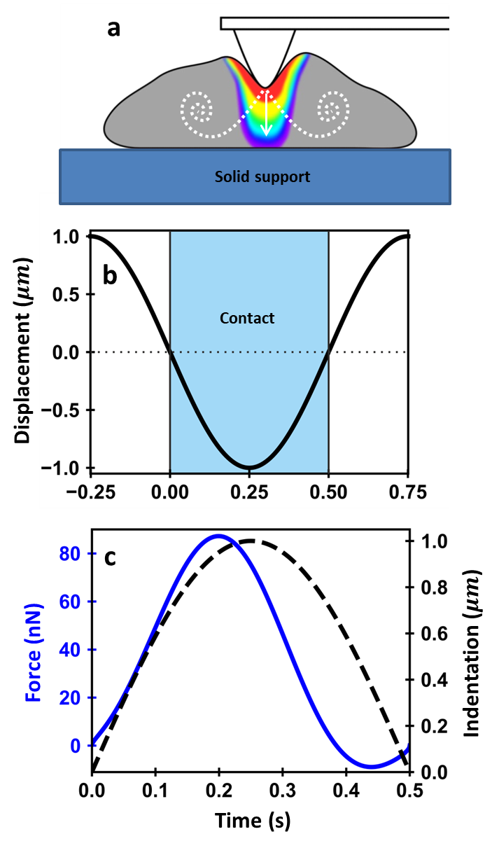
Figure 1. (a) Scheme of the probe-cell-solid support interface in a force-distance measurement. The changes in the color and the discontinuous line provide a qualitative indication of the stress variation and viscous flow across the interface (stress from high to low, red>yellow>green>blue). (b) Probe’s displacement as a function of time for a modulation frequency of 1 Hz. In a force-distance curve experiment, the probe is approached towards the cell until mechanical contact is established. We define t=0 as the time when the probe contacts the cell for the first time. We shade in blue the section of the modulation period in which the probe is contact with the cell. (c) Cell’s indentation (discontinuous black line) and tip-cell force (continuous blue line) as a function of time. Sample parameters, E = 4 kPa, η_{G} = 100 Pa s, h=2.5 μm. Simulations for a spherical probe of R= 5μm.

Bottom effect viscoelastic theory for a thin viscoelastic layer on top of a rigid support

The Young’s modulus and the viscosity coefficient of a cell has been determined by fitting the experimental force-distance curves with the force provided by using eqn 10²⁴. However, eqn 10 considers the cell as a semi-infinite system or, in practical terms, much thicker than the deformations involved in the experiment. In a typical force-distance curve experiment, the probe indents the cell from 300 to 1500 nm. Those values could represent 10 to 30% of the cell’s thickness depending on the lateral position of the probe with respect to the cell’s nucleus. The stress applied by the probe could reach the cell-solid support interface (fig. 1a). Then, the force-distance curve would bear information on the solid support stiffness.

Several methods have been proposed to determine the elastic force exerted by a spherical probe on a cell adherent to a semi-infinite and rigid support³⁰⁻³¹. The most general bottom effect elastic theory considers the following expression to determine the force as a function of the indentation³¹
$F(I)=\sum_{j=0}^{N}{α_{j}EI^{β_{j}}=\sum_{j=0}^{N}{F_{j}}}$ (11)

The coefficients $α_{j}$ and $β_{j}$ depend on the geometry of the probe and the thickness of the layer. The equivalent expression for a finite viscoelastic layer is obtained by applying the elastic-viscoelastic equivalence principle to each term of the above equation, then
$F(I\left(t\right),t)=\sum_{j=0}^{N}{α_{j}\int_{0}^{t}{φ_{E} (t-t')\frac{d}{dt'}\left({I(t')}^{β_{j}}\right)}dt'}$ (12)
This equation is valid for any linear viscoelastic material. By introducing the relaxation function (eqn 7) we deduce the force expression for a Kelvin-Voigt material
$F(I\left(t\right),t)=\sum_{j=0}^{N}{α_{j}{I(t)}^{β_{j}-1}\left[β_{j}η_{G}\dot{I}(t)+EI(t)\right]}$ (13)
The terms and coefficients for cylinder (flat punch), spherical and conical probes are presented in tables 1, 2 and 3. The above probe geometries are the most common in the AFM-based force-distance curve experiments. The coefficients have been calculated by considering a realistic model (non-Hertzian) to determine the change of the contact area with the indentation³¹. The force applied on a semi-infinite material corresponds to the index j=0.
The tables show that the different terms and coefficients up to j=4. Those terms generate lengthy analytical equations. To facilitate the understanding of the role of the different factors that contribute to the force exerted on a viscoelastic material of thickness h deposited on rigid support, we expressed the force by considering only the terms associated with the first two indexes (j=0,1).
For a cylinder of radius a the force is
$F\left[I\left(t\right),t\right]=\frac{8a}{3}\left[3η_{G}\dot{I}+EI\right]+1.133\frac{8}{3}\frac{a^{2}}{h}\left[3η_{G}\dot{I}+EI\right]+O(\frac{a^{3}}{h^{2}})$ (14)
For a parabolic probe of radius R
$F\left[I\left(t\right),t\right]=\frac{16}{9}\sqrt{RI}\left[\frac{9}{2}η_{G}\dot{I}+EI\right]+1.133\frac{16}{9h}RI\left[6η_{G}\dot{I}+EI\right]+O\left(\frac{I^{3/2}}{h^{2}}\right)$ (15)
For a conical probe of half angle θ
$F\left[I\left(t\right),t)\right]=\frac{8\tan{θ}}{3π}I\left[6η_{G}\dot{I}+EI\right]+1.7795\frac{16\tan^{2}θ}{3πh}I^{2} \left[9η_{G}\dot{I}+EI\right]+O\left(\frac{I^{3}}{h^{2}}\right)$ (16)
The above expression shows that the force depends on intrinsic parameters of the sample such as E and η_{G}, parameters of the probe such as R, a or θ, and operational parameters such as the indentation and its rate. The above expressions also indicate that the force components associated with dissipative processes are magnified by the bottom effect.
Table 1. Bottom effect viscoelastic terms for a cylinder of radius a indenting linear viscoelastic sample of thickness h.
j | α_{j} | β_{j} | F_{j} (cylinder)
0 | $$\frac{8}{3}a$$ | 1 | $$\frac{8a}{3}\left[3η_{G}\dot{I}(t)+EI(t)\right]$$
1 | $$1.133\frac{8}{3}a{\left(\frac{a}{h}\right)}^{1}$$ | 1 | $$1.133\frac{8}{3}a{\left(\frac{a}{h}\right)}^{1}\left[3η_{G}\dot{I}(t)+EI(t)\right]$$
2 | $$1.283\frac{8}{3}a{\left(\frac{a}{h}\right)}^{2}$$ | 1 | $$1.283\frac{8}{3}a{\left(\frac{a}{h}\right)}^{2}\left[3η_{G}\dot{I}(t)+EI(t)\right]$$
3 | $$0.598\frac{8}{3}a{\left(\frac{a}{h}\right)}^{3}$$ | 1 | $$0.598\frac{8}{3}a{\left(\frac{a}{h}\right)}^{3}\left[3η_{G}\dot{I}(t)+EI(t)\right]$$
4 | $$-0.291\frac{8}{3}a{\left(\frac{a}{h}\right)}^{4}$$ | 1 | $$-0.291\frac{8}{3}a{\left(\frac{a}{h}\right)}^{4}\left[3η_{G}\dot{I}(t)+EI(t)\right]$$

Table 2. Bottom effect viscoelastic correction terms for a conical probe (half angle θ) indenting a viscoelastic layer of thickness h.

j | α(j) | β(j) | F_{j} (cone)
0 | $$\frac{8\tan{θ}}{3π}$$ | 2 | $$\frac{8\tan{(θ)}}{3π}I\left[6η_{G}\dot{I}(t)+EI(t)\right]$$
1 | $$0.721\frac{8 \tan^{2}θ}{3hπ}$$ | 3 | $$0.721\frac{8 \tan^{2}θ}{3hπ}I^{2} \left[9η_{G}\dot{I}(t)+EI(t)\right]$$
2 | $$0.650\frac{8 \tan^{3}θ}{3h^{2}π}$$ | 4 | $$0.650\frac{8 \tan^{3}θ}{3h^{2}π}I^{3}\left[12η_{G}\dot{I}(t)+EI(t)\right]$$
3 | $$0.491\frac{8 \tan^{4}θ}{3h^{3}π}$$ | 5 | $$0.491\frac{8 \tan^{4}θ}{3h^{3}π}I^{4}\left[15η_{G}\dot{I}(t)+EI(t)\right]$$
4 | $$0.225\frac{8 \tan^{5}θ}{3h^{4}π}$$ | $$6$$ | $$0.225\frac{8 \tan^{5}θ}{3h^{4}π}I^{5}\left[18η_{G}\dot{I}(t)+EI(t)\right]$$

Table 3. Bottom effect viscoelastic correction terms for a parabolic probe (apex radius R) indenting a linear viscoelastic layer of thickness h.
j | α(j) | β(j) | F_{j} (sphere)
0 | $$\frac{16}{9}R^{\frac{1}{2}}$$ | $$\frac{3}{2}$$ | $$\frac{16}{9}R^{\frac{1}{2}}{I(t)}^{\frac{1}{2}}\left[\frac{9}{2}η_{G}\dot{I}(t)+EI(t)\right]$$
1 | $$1.133\frac{1}{h}\frac{16}{9}R$$ | 2 | $$1.133\frac{1}{h}\frac{16}{9}RI(t)\left[6η_{G}\dot{I}(t)+EI(t)\right]$$
2 | $$1.497\frac{1}{h^{2}}\frac{16}{9}R^{\frac{3}{2}}$$ | $$\frac{5}{2}$$ | $$1.497\frac{1}{h^{2}}\frac{16}{9}R^{\frac{3}{2}}{I(t)}^{\frac{3}{2}}\left[\frac{15}{2}η_{G}\dot{I}(t)+EI(t)\right]$$
3 | $$1.469\frac{1}{h^{3}}\frac{16}{9}R^{2}$$ | 3 | $$1.469\frac{1}{h^{3}}\frac{16}{9}R^{2}{I(t)}^{2}\left[9η_{G}\dot{I}(t)+EI(t)\right]$$
4 | $$0.755\frac{1}{h^{4}}\frac{16}{9}R^{\frac{5}{2}}$$ | $$\frac{7}{2}$$ | 0.755$\frac{1}{h^{4}}\frac{16}{9}R^{\frac{5}{2}}{I(t)}^{\frac{5}{2}}\left[\frac{21}{2}η_{G}\dot{I}(t)+EI(t)\right]$

Efremov et al.³⁹ have recently introduced a bottom effect viscoelastic correction based on the application of Lee and Radok’s method⁵⁹. However, their approach does not lead to analytical expressions for the force.

RESULTS AND DISCUSSION
Consistency of the bottom effect viscoelastic theory
Figure 2 illustrates the dependence of the force exerted on a cell (h= 5 μm) as a function of time and the indentation for a tip-cell distance modulation given by
$d=A\sin{(}2πf_{m}t$) (17)
The force is calculated for three representative probe geometries, cylinder (Fig. 2a-c), sphere (Fig. 2d-f) and cone (Fig. 2g-i). For a given probe geometry, the force is calculated by including different terms in the polynomial expression (eqn 11) with the following convention, zero order means F=F₀; 1st order means F=F₀+F_{1;} 2nd order means F=F₀+F₁+F₃ and so on. In all the case the term F₀ coincides with the force exerted by the probe on a semi-infinite sample with the same properties than the finite layer.
Figure 2 shows that the force applied on the cell (finite layer) is larger than the one exerted on a semi-infinite sample. More importantly, the force converges as the order of the polynomial is increased. This result represents an internal validation of the theory. We have verified that the above results are valid for other type of tip-cell distance modulations, in particular, for triangular waveforms.
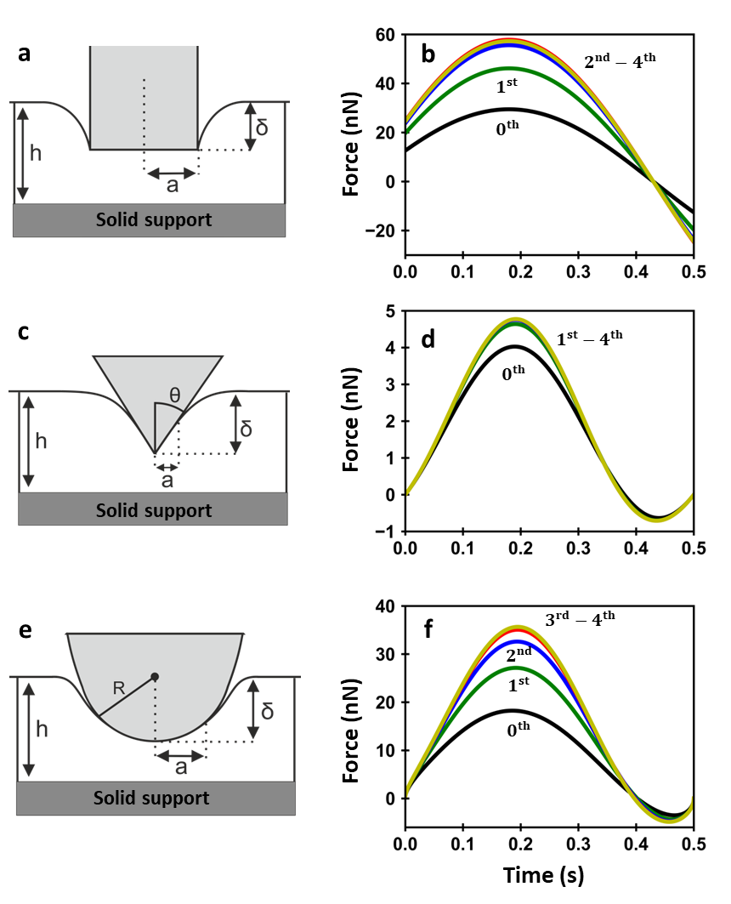
Figure 2. Force-time and indentation curves for cylindrical, conical and spherical probes as a function of the approximation order. a. Force exerted on a viscoelastic sample by a cylinder (a= 2.5 μm). b. Force exerted on a viscoelastic sample by a conical probe (cone half-angle= 45º). c. Force exerted on a viscoelastic sample by a sphere (R= 5 μm). The force-time curves have been determined by using the bottom effect viscoelastic expressions (eqn. 11). The probe displacement as a function of time is shown in Fig. 1b (I_{max}= 1 μm). Sample parameters, E = 4 kPa, η_{G} = 100 Pa s; f_{m} =1 Hz.

Force-time and indentation curves for a thin viscoelastic layer on top of a rigid support
Figure 3 shows the force exerted on a viscoelastic layer by an axisymmetric probe for different layer thicknesses. The results are presented for a cylinder (Fig. 3a-b), sphere (Fig. 3c-d) and cone (Fig. 3e-f). For the three geometries, the force reaches its maximum (peak force) before the tip reaches its maximum indentation. The time shift between both maxima reflects the competition between the conservative force, which increases with the indentation, and the viscous force, which opposes the probe motion and it is proportional to the indentation rate (see below).
The force exerted on a viscoelastic layer depends on the layer thickness. For the same indentation, the peak force increases by decreasing the layer thickness (Figs 3a, c, e). This result reflects the influence on the substrate stiffness on the force measured by the AFM. The force (see for example Table 1) contain terms that depend on the contact area/thickness ratio. The influence of the substrate is magnified on a cell because of its finite thickness (~1-20 μm) range and its very small Young’s moduli values (~10²-10⁴ Pa).
By knowing the tip’s displacement (eqn 17) it is straightforward to transform the force-time curves into force-indentation curves (Figs. 3b, d and f). In fact, this is the most common AFM approach to obtain information about the nanomechanical properties of a cell⁸. It is observed that the approach and retraction parts of the force-distance curves do not overlap (hysteresis loop). This result is a direct consequence of the energy dissipating processes associated with a viscoelastic response. Upon contact, the viscous force acts as a repulsive force that reduces the total force. This behavior is in contrast with the one shown by an elastic material. There the peak force grows monotonically by increasing the indentation³¹. We also observe that the force takes higher values during the approach. In the retraction section, the viscosity results in an effective attractive force.
Figures 3a and 3b show an interesting feature. If there is tip-cell contact, the force has a non-zero value for an infinitesimal indentation. This feature is exclusive of cylindrical tips (see eqns 14-16). It reflects the contribution of two factors. First, the force depends on both the indentation and the indentation rate. Second, the contact area of a cylindrical tip changes in a discontinuous manner from zero before contact to the area of the flat section of the cylinder. From then on, the contact area remains constant until the tip is detached from the cell. As a consequence, the force on the cell could be different from zero for an infinitesimal deformation due to the term that depends on the speed. The same factor explains that the value of the force changes sign from positive (approach) to negative (retraction).
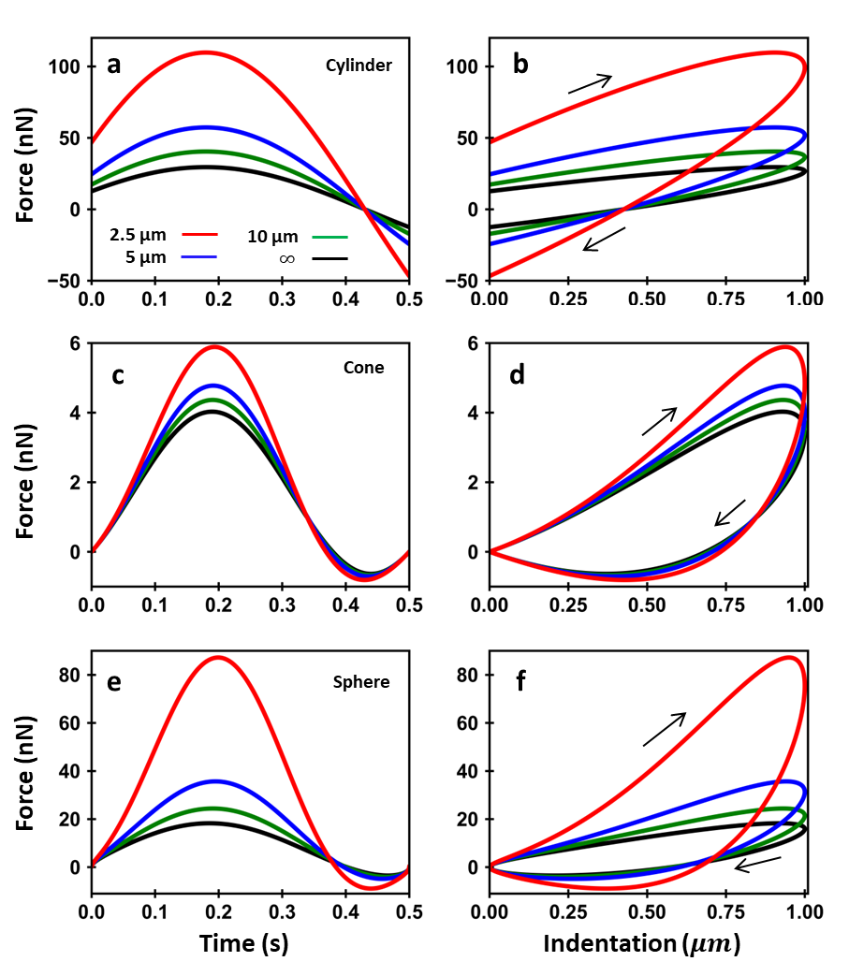

Figure 3. Force-time and distance (indentation) curves for different layer thickness. (a). Force-time curves exerted by a cylinder (a=2.5 μm) on a viscoelastic sample. (b). Force-distance curves from a. (c). Force-time curves exerted by a cone (half-angle= 45º) on a viscoelastic sample. (d). Force-distance curves from c. (e). Force-time curves exerted by a spherical probe (R= 5 μm) on a viscoelastic sample. (f). Force-distance curves from e. The force-time and distance curves have been determined by using the bottom effect viscoelastic theory (eqn 13 and including all the terms given in the tables). The probe displacement as a function of time is shown in Fig. 1b (I_{max}= 1 μm). Sample parameters, E = 4 kPa, η_{G} = 100 Pa s; f_{m} =1 Hz.

Comparison between bottom effect theory and finite element simulations
To test the validity of the above expressions we have compared the force-distance curves deduce from the bottom effect viscoelastic theory with the force-distance curves obtained from finite element method (FEM) simulations. For each probe geometry, we have simulated two different interfaces. The probe-finite viscoelastic layer-rigid support (Fig. 4a, c and d) and the probe-semi-infinite viscoelastic layer interface (Fig. 4b, d and f). The probe-finite layer-rigid support interface simulates a force spectroscopy experiment where the finite layer replaces the cell. In this comparison, the results provided by the FEM simulations are considered to provide the true behavior of the viscoelastic material. The FEM results obtained for the semi-infinite layer while attempting to describe the real experimental interface will illustrate and justify the need for having a bottom-effect viscoelastic theory. The numerical simulations were performed by using the COMSOL software (COMSOL Multiphysics, COMSOL AB, Stockholm, Sweden).
In the FEM simulations the probe is is an isotropic and homogeneous elastic material characterized by a Young’s modulus of 20 GPa. The layer was simulated by a cylinder of length and radius, respectively, of 5 and 50 µm. For the semi-infinite layer, the length and radius were respectively, of 50 and 50 µm. The boundary condition for the rigid support implies zero displacements in the in an out-plane directions. The tip-layer distance was modulated by a sinusoidal waveform with a frequency of f_{m} = 1 Hz.
To optimize the computational time, we have chosen different mesh sizes. Near the probe, the mesh size was of 0.02 µm while far from the probe-sample interface was 1 μm (Fig. 4). The simulations were performed assuming a frictionless contact and cylindrical symmetry. The sample mechanical response was characterized by a linear viscoelastic Kelvin-Voigt material with parameters of E = 4 kPa, η_{G} = 100 Pa s. Those values are based on force spectroscopy measurements performed on fibroblast cells²⁴.
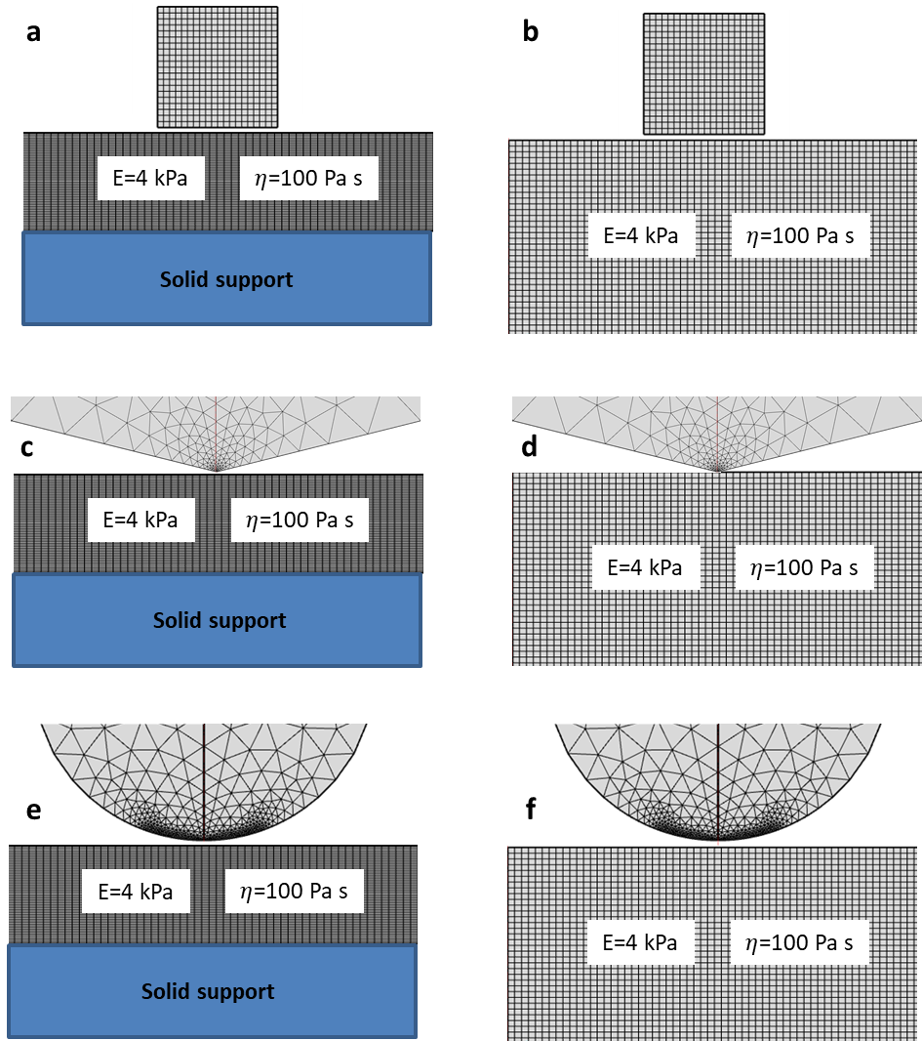
Figure 4 (a). FEM scheme of the interface formed by a cylindrical probe on top of a linear viscoelastic layer deposited on a rigid support. (b) FEM scheme of the interface formed by a cylindrical probe on top of a semi-infinite linear viscoelastic sample. (c) FEM scheme of the interface formed by a conical probe on top of a linear viscoelastic layer deposited on a rigid support. (d) FEM scheme of the interface formed by a conical probe on top of a semi-infinite linear viscoelastic sample. (e) FEM scheme of the interface formed by a half-sphere on top of a linear viscoelastic layer deposited on a rigid support. (f). FEM scheme of a half-sphere on top of a semi-infinite linear viscoelastic sample. The sample either finite or semi-infinite has a Kelvin-Voigt behavior with parameters, E_{s} = 4 kPa, η_{G} = 100 Pa s. The simulated systems have cylindrical symmetry around the vertical axis (red line).
Figure 5 compares the force-time curves obtained, respectively with FEM, bottom effect and semi-infinite approaches. For the three probes, we observe a good quantitative agreement between the bottom effect theory and FEM simulations. In fact, the agreement is excellent during the approach. The peak force values are almost identical (relative error below 1%). Some differences are observed between FEM and bottom effect results when the tip is withdrawn from the cell. The bottom-effect viscoelastic theory shows the existence on an attractive force. The attractive force is a manifestation of the viscous force that opposes the tip pulling away from the layer. However, this effect is not present in the FEM simulations. It is related to the way the contact area is modeled in the theory. In the bottom effect model the area decreases continuously while in the FEM simulations, the contact area vanishes to zero in a sharp manner²⁴. In the FEM simulations the viscoelastic layer is relaxed when the tip pulls away from the surface (relaxation time of the layer is 0.025 s). The theory does not consider this effect because it has been deduced by using a contact area-indentation change based on an elastic model. As a consequence, only the approach or the repulsive section very close to the peak value of the force-distance curve should be considered to deduce the viscoelastic parameters. Ting’s model⁶⁰⁻⁶¹ determines the contact area during the probe’s retraction. However, the contact area is solved numerically which would significantly complicate this bottom effect viscoelastic theory.
The viscoelastic theory for a semi-infinite layer fails to match the FEM data (eqn 8). This theory provide forces (absolute values) that are several times smaller or larger than the true forces (FEM simulations). This result underlines the need to apply a bottom effect viscoelastic correction.
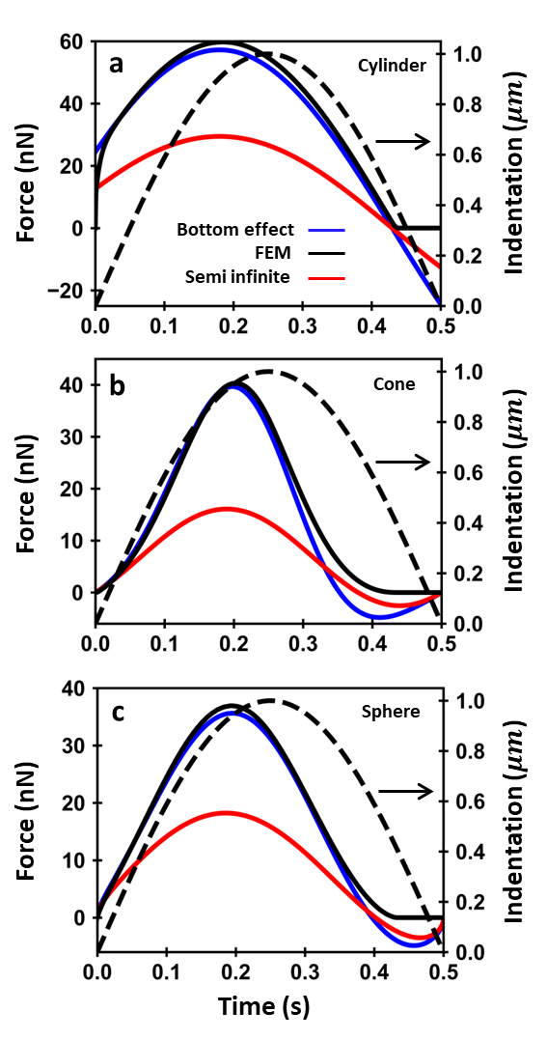
Figure 5. Botom effect, FEM and semi-infinite force-time curves. (a) Cylinder (a=2.5 μm). (b) Cone (half-angle=76º). (c) Parabolic tip (R=5 μm). The indentation is plotted as a dashed line. The medium was a Kelvin-Voigt viscoelastic material (E = 4 kPa, η_{G} = 100 Pa s); h=5 μm.; f_{m} =1 Hz.

Determination of viscoelastic parameters from force-distance curves
The validity of the bottom effect viscoelastic theory is tested by comparing the viscoelastic parameters (E and η) deduced by fitting the force-distance curves generated by the FEM with the expressions of the theory (eqn 11 and tables 1, 2 and 3). By fitting those curves with the theoretical expressions, the viscoelastic parameters of the cell as a function of the indentation/sample thickness ratio are deduced. In this context, we consider that FEM simulations provide the true force-distance curves to test the validity of the theory. To illustrate the importance of using a bottom effect viscoelastic theory we also plot the date obtained from semi-infinite theories (eqn 8). Simulations and theoretical results are provided for three representative probe geometries, cylinder, cone and sphere.
Figure 6 shows the Young’s modulus and the viscosity coefficient dependencies on the tip’s indentation for a 5 μm thick viscoelastic layer. The bottom effect viscoelastic theory recovers the Young’s modulus and the viscosity coefficient of the cell from the force-distance curve. The green stripe shows the values that lie within a 10% window from the Young’s modulus and viscosity of the sample. The agreement is within less than 1% for all the cases except the viscosity coefficient for a conical probe. In that case the relative error is in the 5-10% range.
On the other hand, the parameters provided by semi-infinite models introduce large relative errors (100-300% range), even for small indentation/layer thickness ratios. For example, an indentation/layer ratio of 0.05 (sphere) would produce with relative errors in the determination of Young’s modulus and the viscosity coefficient, respectively, of 50 and 9%.
Furthermore, for conical and spherical probes the relative error in the determination the Young’s modulus and the viscosity coefficient increase by increasing the indentation (or the indentation ratio). For a cylinder, the discrepancy between the FEM values and those provided by the semi-infinite model does not depend on the indentation ratio. This is because the contact are does not depend on the indentation. Figure 6d shows that the viscosity coefficient goes to zero as the indentation is increased. This is another consequence of using the wrong model (semi-infinite) to fit the data. Overall, the above results show that semi-infinite models are unsuitable to describe the properties of soft viscoelastic layers, in particular, living cells. These findings emphasize the need of using the bottom effect viscoelastic theory even for very small indentation ratios.

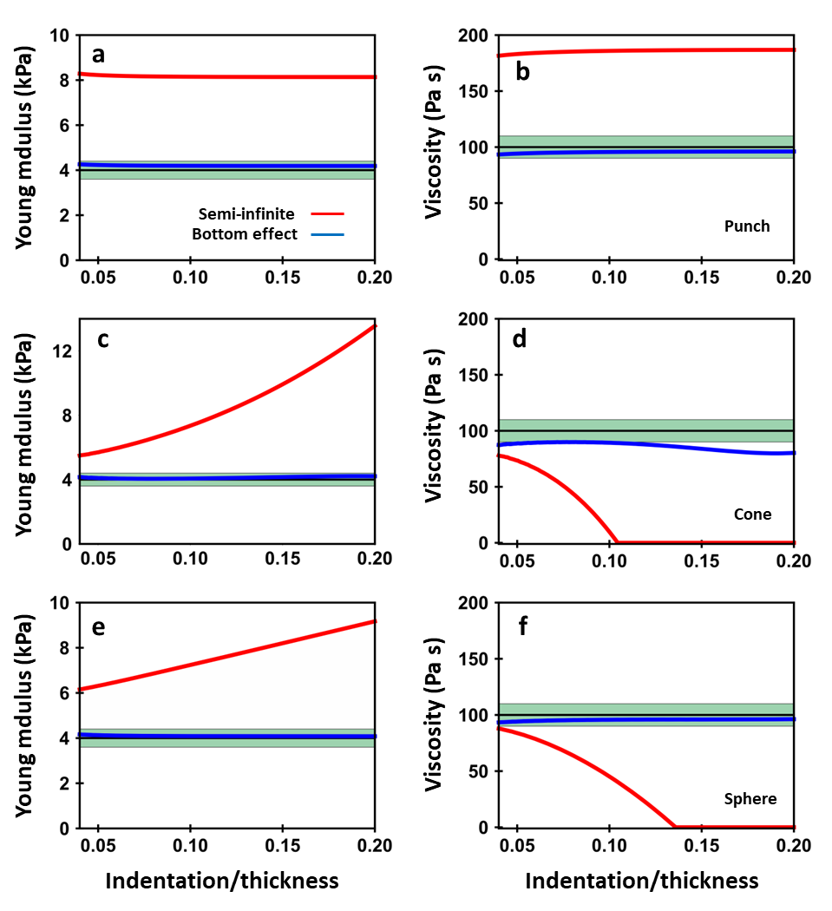
Figure 6. Determination of the viscoelastic parameters of a cell from bottom effect and semi-infinite theories. (a). Cylinder of a=2.5 μm. (b). Conical tip of θ=76º. (c). Parabolic tip of R= 5 μm. The elastic moduli and viscosity coefficient are plotted as a function of the indentation/thickness ratio (h=5 μm). The bottom effect viscoelastic corrections have been calculated by using the force terms included, respectively, in Tables 1, 2 and 3. The force-distance curves have been generated by FEM simulations for a 5 μm thick sample with Young’s modulus 4 kPa and η_{G}=100 Pa s. The green stripe shows the values that lie within a 10% window of the parameters of the FEM model. Triangular indentation with a f_{m}= 1 Hz.

CONCLUSIONS

The force exerted by a probe on a living cell is influenced by the stiffness of the rigid support. We have developed a bottom effect viscoelastic theory to describe the forces and deformations experienced by an adherent cell cultured on a rigid support. The theory provides the expression of the force as convolution integral which takes into account the viscoelastic parameters of the cell, the geometry of the probe, the thickness of the sample, the indentation and the indentation rate. This theory enables to determine the force applied on a cell as a function of the its thickness and the indentation depth.
The theory is based in the application of the reciprocal theorem to relate pressures and deformations for different geometries, the equivalence principle between elastic and viscoelastic deformations and the set of boundary conditions involving a cell adhered on to a rigid support. Analytical expressions of the force are deduced for cylinder, conical and paraboloid probes by assuming the cell as an incompressible, finite and linear viscoelastic layer following a Kelvin-Voigt stress-strain response. This model represents a good approximation to describe the behavior of eukaryotic cells at low modulation frequencies. The theory shows that the force exerted on a cell is increased by the presence of the solid support. This result is an unavoidable consequence of the boundary conditions existing in AFM experiments. Despite of this effect, the bottom effect viscoelastic theory enables to recover the intrinsic mechanical properties of the cell such as the Young’s modulus and the viscosity coefficient with independence of the stiffness of the rigid support
The force-distance curves obtained from the bottom effect viscoelastic theory are compared with those obtained by using finite element simulations. Satisfactory quantitative agreements are obtained for indentation/layer thickness ratios up to 0.3. The differences observed between the FEM simulations and the bottom effect viscoelastic theory happen when the tip is withdrawn from the sample. Those differences are associated with the determination of the contact area. In the simulations the contact area during the withdrawal shrinks at a faster rate than the one predicted by the theory. For that reason, the fitting between theory and experiment should be performed on the approach section of the force-distance curves.
We also show that the cell’s nanomechanical parameters deduced by fitting a force-distance curve with a semi-infinite viscoelastic model are far from the true values. The discrepancies increase with the indentation ratio. Even for small indentation ratios (≤0.05), the semi-infinite model fails to reproduce the data.
In summary, the force exerted by a probe on a viscoelastic layer is influenced by the stiffness of the solid support. It depends on the layer thickness, the indentation, the indentation rate and the probe shape. As a rule, the force applied on a cell is dominated by the stiffness of the support even for very small indentations (100-500 nm). The bottom-effect viscoelastic theory enables to recover the viscoelastic parameters of the cell with a relative error below 10% for relatively large indentation/layer ratios (≤0.3).
The theory is general. It can be extended to any axisymmetric probe geometry. The fundamental expressions can be applied to different linear viscoelastic models such as the standard linear solid and power law rheology.

Acknowledgments
We thank the financial support from the European Research Council ERC–AdG–340177 (3DNanoMech) and the Ministerio de Economía y Competitividad MAT2016-76507-R.

References

1. D. Wang and T. P. Russell, Macromolecules, 2018, 51, 3-24.
2. R. García, R. Magerle and R. Perez, Nat. Mater., 2007, 6, 405.
3. C. Marius, L. Y. Seth and V. T. Vladimir, Jpn. J. Appl. Phys., 2015, 54, 08LA02.
4. E. T. Herruzo, A. P. Perrino and R. Garcia, Nat. Commun., 2014, 5, 3126.
5. R. Proksch, M. Kocun, D. Hurley, M. Viani, A. Labuda, W. Meinhold and J. Bemis, Journal of Applied Physics, 2016, 119, 134901.
6. K. N. Hung, I. Makiko and N. Ken, Jpn. J. Appl. Phys., 2016, 55, 08NB06.
7. M. Kocun, A. Labuda, W. Meinhold, I. Revenko and R. Proksch, ACS Nano, 2017, 11, 10097-10105.
8. Y. F. Dufrêne, T. Ando, R. Garcia, D. Alsteens, D. Martinez-Martin, A. Engel, C. Gerber and D. J. Müller, Nat. Nanotechnol., 2017, 12, 295.
9. M. Dong, S. Husale and O. Sahin, Nat. Nanotechnol., 2009, 4, 514.
10. I. D. Medalsy and D. J. Müller, ACS Nano, 2013, 7, 2642-2650.
11. A. P. Perrino and R. Garcia, Nanoscale, 2016, 8, 9151-9158.
12. L. Liu, Q. Li, S. Zhang, X. Wang, S. V. Hoffmann, J. Li, Z. Liu, F. Besenbacher and M. Dong, Advanced science (Weinheim, Baden-Wurttemberg, Germany), 2016, 3, 1500369.
13. C. A. Amo, A. P. Perrino, A. F. Payam and R. Garcia, ACS Nano, 2017, 11, 8650-8659.
14. W. H. Roos, R. Bruinsma and G. J. L. Wuite, Nature Physics, 2010, 6, 733.
15. A. Ortega-Esteban, A. J. Pérez-Berná, R. Menéndez-Conejero, S. J. Flint, C. S. Martín and P. J. de Pablo, Sci. Rep., 2013, 3, 1434.
16. K. Haase and A. E. Pelling, Journal of The Royal Society Interface, 2015, 12.
17. C. Rotsch and M. Radmacher, Biophys. J., 2000, 78, 520-535.
18. J. Alcaraz, L. Buscemi, M. Grabulosa, X. Trepat, B. Fabry, R. Farre and D. Navajas, Biophys. J., 2003, 84, 2071-2079.
19. C. Roduit, S. Sekatski, G. Dietler, S. Catsicas, F. Lafont and S. Kasas, Biophys. J., 2009, 97, 674-677.
20. A. Raman, S. Trigueros, A. Cartagena, A. P. Z. Stevenson, M. Susilo, E. Nauman and S. A. Contera, Nat. Nanotechnol., 2011, 6, 809.
21. R. Vargas-Pinto, H. Gong, A. Vahabikashi and M. Johnson, Biophys. J., 2013, 105, 300-309.
22. J. R. Staunton, B. L. Doss, S. Lindsay and R. Ros, Sci. Rep., 2016, 6, 19686.
23. H. Schillers, C. Rianna, J. Schäpe, T. Luque, H. Doschke, M. Wälte, J. J. Uriarte, N. Campillo, G. P. A. Michanetzis, J. Bobrowska, A. Dumitru, E. T. Herruzo, S. Bovio, P. Parot, M. Galluzzi, A. Podestà, L. Puricelli, S. Scheuring, Y. Missirlis, R. Garcia, M. Odorico, J.-M. Teulon, F. Lafont, M. Lekka, F. Rico, A. Rigato, J.-L. Pellequer, H. Oberleithner, D. Navajas and M. Radmacher, Sci. Rep., 2017, 7, 5117.
24. P. D. Garcia, C. R. Guerrero and R. Garcia, Nanoscale, 2017, 9, 12051-12059.
25. A. F. Christ, K. Franze, H. Gautier, P. Moshayedi, J. Fawcett, R. J. Franklin, R. T. Karadottir and J. Guck, J. Biomech., 2010, 43, 2986-2992.
26. M. Lekka, K. Pogoda, J. Gostek, O. Klymenko, S. Prauzner-Bechcicki, J. Wiltowska-Zuber, J. Jaczewska, J. Lekki and Z. Stachura, Micron, 2012, 43, 1259-1266.
27. J. G. Goetz, S. Minguet, I. Navarro-Lerida, J. J. Lazcano, R. Samaniego, E. Calvo, M. Tello, T. Osteso-Ibanez, T. Pellinen, A. Echarri, A. Cerezo, A. J. Klein-Szanto, R. Garcia, P. J. Keely, P. Sanchez-Mateos, E. Cukierman and M. A. Del Pozo, Cell, 2011, 146, 148-163.
28. A. Fuhrmann, J. R. Staunton, V. Nandakumar, N. Banyai, P. C. Davies and R. Ros, Phys. Biol., 2011, 8, 015007.
29. H. V. Guzman, P. D. Garcia and R. Garcia, Beilstein Journal of Nanotechnology, 2015, 6, 369-379.
30. E. K. Dimitriadis, F. Horkay, J. Maresca, B. Kachar and R. S. Chadwick, Biophys. J., 2002, 82, 2798-2810.
31. P. D. Garcia and R. Garcia, Biophys. J., 2018, 114, 2923-2932.
32. C. T. Lim, E. H. Zhou and S. T. Quek, J. Biomech., 2006, 39, 195-216.
33. P. Kollmannsberger and B. Fabry, Annual Review of Materials Research, 2011, 41, 75-97.
34. R. E. Mahaffy, C. K. Shih, F. C. MacKintosh and J. Käs, Phys. Rev. Lett., 2000, 85, 880-883.
35. V. Vadillo-Rodriguez, T. J. Beveridge and J. R. Dutcher, J. Bacteriol., 2008, 190, 4225-4232.
36. E. Moeendarbary, L. Valon, M. Fritzsche, A. R. Harris, D. A. Moulding, A. J. Thrasher, E. Stride, L. Mahadevan and G. T. Charras, Nat. Mater., 2013, 12, 253.
37. F. M. Hecht, J. Rheinlaender, N. Schierbaum, W. H. Goldmann, B. Fabry and T. E. Schaffer, Soft matter, 2015, 11, 4584-4591.
38. A. Rigato, A. Miyagi, S. Scheuring and F. Rico, Nature Physics, 2017, 13, 771.
39. Y. M. Efremov, W.-H. Wang, S. D. Hardy, R. L. Geahlen and A. Raman, Sci. Rep., 2017, 7, 1541.
40. M. Macis, F. Lugli and F. Zerbetto, ACS Applied Materials & Interfaces, 2017, 9, 19552-19561.
41. L. M. Rebelo, J. S. de Sousa, J. Mendes Filho and M. Radmacher, Nanotechnology, 2013, 24, 055102.
42. J. Rother, H. Nöding, I. Mey and A. Janshoff, Open Biology, 2014, 4, 140046.
43. J. Tamayo and R. Garcia, Applied Physics Letters, 1998, 73, 2926-2928.
44. B. Gotsmann, C. Seidel, B. Anczykowski and F. Harald, Conservative and dissipative tip-sample interaction forces probed with dynamic AFM, 1999.
45. A. Schirmeisen and H. Hölscher, Physical Review B, 2005, 72, 045431.
46. R. Garcia, C. J. Gomez, N. F. Martinez, S. Patil, C. Dietz and R. Magerle, Phys. Rev. Lett., 2006, 97, 016103.
47. E. A. López-Guerra and S. D. Solares, Beilstein Journal of Nanotechnology, 2014, 5, 2149-2163.
48. S. D. Solares, Beilstein J Nanotechnol, 2016, 7, 554-571.
49. F. Crippa, P.A. Thoren, D. Forchheimer, R. Borgani, B. Rothen-Rutishauser, A. Petri-Fink and D. B. Haviland, Soft matter, 2018, 14, 3998-4006.
50. L. Cheng, X. Xia, W. Yu, L. E. Scriven and W. W. Gerberich, Journal of Polymer Science Part B: Polymer Physics, 1999, 38, 10-22.
51. B. R. Bruckner, H. Noding and A. Janshoff, Biophys. J., 2017, 112, 724-735.
52. J. S. de Sousa, J. A. C. Santos, E. B. Barros, L. M. R. Alencar, W. T. Cruz, M. V. Ramos and J. Mendes Filho, Journal of Applied Physics, 2017, 121, 034901.
53. N. Peela, F.S. Sam, W. Christenson, D. Troung, A.W. Watson, G. Mouneimne, R. Ros, M. Nikkhah, Biomaterials 2016, 81, 72-83.
54. L. D. Landau, E. M. Lifshitz, A. M. Kosevich and L. P. Pitaevskii, in Theory of Elasticity (Third Edition), Butterworth-Heinemann, Oxford, 1986, DOI: https://doi.org/10.1016/B978-0-08-057069-3.50008-5, pp. 1-37.
55. N. W. Tschoegl, in The Phenomenological Theory of Linear Viscoelastic Behavior: An Introduction, ed. N. W. Tschoegl, Springer Berlin Heidelberg, Berlin, Heidelberg, 1989, DOI: 10.1007/978-3-642-73602-5_2, pp. 35-68.
56. K. L. Johnson, Contact Mechanics, Cambridge University Press, Cambridge, 1985.
57. I. N. Sneddon, International Journal of Engineering Science, 1965, 3, 47-57.
58. H. H. Hilton, Journal of elasticity and the physical science of solids, 2001, 63, 221-251.
59. E. H. Lee and J. R. M. Radok, Journal of Applied Mechanics, 1960, 27, 438-444.
60. T. C. T. Ting, Journal of Applied Mechanics, 1966, 33, 845-854.
61. T. C. T. Ting, Journal Applied Mechanics 1968, 35, 248-254.

