Dynamics of breaking intermolecular bonds in high-speed force spectroscopy
Manuel R. Uhlig, Carlos A. Amo, Ricardo Garcia*
Materials Science Factory Instituto de Ciencia de Materiales de Madrid, CSIC Sor Juana Inés de la Cruz, 28049 Madrid, Spain
*Correspondence to: r.garcia@csic.es

Abstract
Atomic force microscope based single-molecule force spectroscopy provides a description of a variety of intermolecular interactions such as those occurring between receptor molecules and their ligands. Advances in force spectroscopy have enabled to perform the measurements at high-speeds and sub-microsecond resolutions. We report experiments performed on a biotin-avidin system that reveal that the measured force decreases with the loading rate at high rates. This result is at odds with the established Bell-Evans theory that predicts a monotonic increase of the rupture force with the loading rate. We demonstrate that inertial and the hydrodynamic forces generated during the breaking of the bond dominate the measured force at high loading rates. We develop a correction factor to incorporate those effects into the Bell-Evans theory. The correction is necessary to obtain accurate values of the intermolecular forces at high speeds.

Atomic force microscope (AFM) based single-molecule force spectroscopy (SMFS) enables a direct, accurate and versatile approach to study biomolecular interactions, processes and properties in biophysics and mechanobiology.¹⁻⁶ Recent applications include the mapping of the first binding steps of a virus to animal cells⁷ or revealing a variety of intermediate steps in the unfolding of membrane proteins.⁸ The miniaturization of the cantilevers has enabled to decrease the force constant at the same time that the fundamental resonant frequency has been increased.^{9,10} Ultrashort cantilevers also reduce the hydrodynamic drag between the cantilever body and the liquid, which in turns reduces the noise and enables to detect smaller rupture force events.¹¹ High-speed force spectroscopy brings closer the direct comparison of force spectroscopy experimental data (10⁻²-10⁻⁵ s) with molecular dynamics simulations of the same systems ~10⁻⁷ s.⁶ The experimental data have stimulated a theoretical activity to understand the processes involved in the transformation of the rupture forces into properties of the intermolecular bonds.^{3,12,13} Stochastic theories have explored the rupture of bonds at very high loading rates.^{14,15} The influence of the pulling device on the measured quantities has also been considered.^{15,16}
A system characterized by the presence of weak non-covalent bonds, the case of ligand-receptor bonds, exhibits a spectrum of rupture forces (bond strengths) as the loading rate at which the force is applied is varied.¹⁷⁻²⁰ The Bell-Evans theory^{3,21} provides the basic understanding of this spectrum of bond strengths for a multi-state model. The theory explains that thermal activation decreases the lifetime of a weak noncovalent bond when a mechanical force is applied. The applied force lowers the energy barriers separating the different bound states and speeds up the dissociation of the bond. The theory predicts that the mean value of the rupture force F_{rup}, increases with the loading rate r according to
$F_{\text{rup}}(r)=-\frac{k_{\text{B}}T}{x_{\text{u}}}\ln\left(\frac{rx_{\text{u}}}{k_{\text{off}}k_{\text{B}}T}\right)$ (1)
where the kinetic parameters are the dissociation constant k_{off} and the effective distance between the bound and unbound states x_{u}, T is the absolute temperature and k_{B} the Boltzmann constant. The above prediction has been verified experimentally in many SMFS experiments performed at low to moderate loading rates (10² to 10⁵ pN/s).^{4,14,18,22-30} In those experiments, the rupture force has been postulated to coincide with the measured force F_{rup}≡F_{m}=kz_{rup} . The measured force is determined from the cantilever deflection at the rupture distance, z_{rup}. The above postulate is considered valid with independence of the loading rate.
Here we demonstrate that the fundamental postulate of AFM-based SMFS does not necessarily apply for experiments performed at high-speed loading rates. Experiments performed on a biotin-avidin system show that the measured force decreases with the loading rate for rates above a certain threshold value. The threshold is defined by the ratio between the resonant frequency of the probe and the pulling speed. For low and moderate loading rates, the measured force follows the Bell-Evans theory. At higher loading rates, the measured force decreases with the loading rate. This trend would prevent the direct use of the experimental data to deduce the kinetics parameters and the energy landscapes of the intermolecular bond.
Biotin-avidin is the prototype ligand-receptor system in SMFS.^{1,17,19,20,23,24,30,31} Fig. 1a shows a scheme of an experiment to measure the rupture forces and bond parameters of the biotin-avidin interactions. Fig. 1b shows a force-distance curve with the signature of a single biotin-avidin unbinding event. The rupture of the bond is preceded by the stretching of the poly(ethylene glycol) PEG linker.^{31,32} Fig. 1c illustrates the change in the force as a function of the pulling speed. For low to moderate pulling speeds, the force increases with the speed. For speeds above 3x10⁴ nm/s the measured force decreases with the loading rate. The histograms provide the statistical support for the above observations (Fig. 1d). The number of individual force-distance curves varied between 100 for the low speed range to 600 for the highest pulling speeds. About 25% of force-distance curves contain specific biotin-avidin events (see Fig. S5 and Fig. S6 Supplementary Information).
The slope of the force as a function of the loading rate shows three different regions (Fig. 2). From 7x10² to 2x10⁴ pN/s the measured force grows linearly with the logarithm of the loading rate. From 2x10⁴ to 8x10⁴ pN/s the slope increases by a factor 3. The measured force reaches a maximum at about 8x10⁴ pN/s from there on the force shows a sharp decrease with the rate. The slope of the curve becomes negative. The first two regions are explained in terms of the existence of two different energy barriers.^{17,19,20} The existence of a negative slope cannot be explained by the Bell-Evans model nor by more sophisticated models.^{12,14}. We attribute the above observation to the generation of dynamic forces during the rupture of the molecular bond.
To describe the dynamics of the pulling device we have approximated the tip-linker-bond system by a 1D model. ^{33,34} It has been shown that the Euler-Bernoulli equation under the application of force at its free end becomes the Newton equation for a point-mass model³⁵. The equation of motion for this system is
$F_{\text{ts}}\left(d\left(t\right),\dot{d}\left(t\right)\right)=kz+\frac{mω_{\text{0}}}{Q}\dot{z }+m\ddot{z}$ (2)
$d\left(t\right)=z_{\text{c}}+z\left(t\right)+A_{\text{p}}g{(ω_{\text{p}}t)}$ (3)
F_{ts} is the instantaneous tip-sample force, g(t) is the distance modulation (triangular or sinusoidal), f₀ =ω₀/2π is the cantilever’s resonant frequency and f_{p} =ω_{p}/2π is the pulling frequency; Q is the quality factor, z_{c} the average probe height and z the cantilever deflection. The tip-sample force is expressed in terms the force obtained from the cantilever deflection and some addition of inertial and hydrodynamic components (eqn 2). When the bond is broken the tip-sample force coincides with the rupture force F_{ts}=F_{rup}. In general, F_{rup}≠F_{m}=kz_{rup}. This result contradicts the fundamental postulate of AFM-based SMFS.
In Fig. 3a we compare the rupture force (Bell-Evans model) and the simulated measured force, F_{m}= kz_{rup.} The rupture force is calculated from eqn (1) with x_{u}=0.138 nm, k_{off} =12.2 s⁻¹. The simulations are performed for two different cantilevers with f₀ of 10 kHz and 100 kHz. The Bell-Evans model provides a linear increase of the rupture force with the logarithm of the loading rate. The forces obtained by solving the Newton equation are indistinguishable from the Bell-Evans model for low to moderate loading rates. The curves depart for loading rates above 2x10⁴ pN/s (f₀=10 kHz). Cantilevers with higher resonant frequencies extend the loading rate range where the curves overlap. For f₀=100 kHz, the curves depart for rates above 2x10⁵ pN/s. At those rates, the inertial and hydrodynamic contributions dominate the cantilever deflection.
Neither the loading rate nor the pulling speed are useful to define the validity range of the force spectroscopy postulate. The loading rate depends on the probe and the pulling speed. The pulling speed v_{p} does not univocally determine the pulling frequency. The speed depends also on the amplitude of the probe displacement. A suitable parameter χ is found by re-writing eqn (2). For a monotonic probe displacement d (see Supplementary)
$F_{\text{ts}}\left(d\right)=kz(d)+\frac{kx_{\text{c}}}{Q}χ\frac{\text{d}z}{\text{d}d}+kx_{\text{c}}^{2}χ^{2}\frac{{\text{d}}^{2}z}{\text{d}d^{2}}$ (4)
where χ is the frequency ratio between the pulling rate (v_{p}/x_{c}) and the resonant frequency of the cantilever, χ= (v_{p}/x_{c})/f₀. We have introduced the mean carbon-carbon distance in an amino acid chain x_{c}=0.15 nm to provide a dimensionless definition for χ. The hydrodynamic and inertial components show, respectively, a linear and quadratic dependence on the frequency ratio χ.
Fig. 3b shows the dependence of the force ratio F_{m}/F_{rup} as a function of the frequency ratio. For small frequency ratios, say below 1, the measured force coincides with the value of the rupture force. For higher χ values, the measured force underestimates the value of the rupture force. A χ=10 gives a relative error of 5% ((F_{rup}-F_{m})/F_{rup}) while for χ=15 and 60, the relative errors are, respectively, ~10% and ~30%.
We have developed a model that incorporates Bell-Evans and Newton dynamics considerations (see Supplementary). The model provides a correction factor N(r) to account for the loading rate dependence associated with the dynamic effects, then
$F_{rup}^{*}=F_{\text{m}}\left(r\right)N\left(r\right)=kz_{\text{rup}}\left(r\right)\left[1+{\left(\frac{rα}{k_{\text{eff}}f_{0}}\right)}^{2}+\frac{rα}{k_{\text{eff}}f_{0}Q}\right]$ (5)
By multiplying the measured forces (Fig. 3a, f₀=10 kHz) with the correction factor we recover the corrected values of the rupture force for higher loading ratios (Fig. 3c); α is a fitting parameter of the model with dimensions of L⁻¹ (see Supplementary). The above correction factor enables to transform the F_{m} values into force values that could be introduced into the Bell-Evans expression (eqn (1)).
Equation 5 has been applied to correct the experimental data shown in Fig. 2. The correction removes the decrease of the unbinding force for high loading rates. By fitting the corrected forces with the Bell-Evans model we find two activation barriers (Fig. 4). From low to moderate loading rates (7x10² to 10⁴ pN/s), the fitting provides the bond parameters x_{u}=0.5±0.06 nm and k_{off}=0.8±0.5 s⁻¹ of the intermediate activation barrier. At higher loading rates we obtain the bond parameters of the inner activation barrier, x_{u}=0.23±0.05 nm and k_{off}=24±20 s⁻¹. The observed activation barriers are related to two different bound biotin-avidin states. Those transitions are in agreement with biomembrane force probe measurements on the same system.¹⁷ The above kinetics parameters are in line with the values obtained in other SMFS experiments on biotin-avidin.^{19,20}
The experimental determination of the rupture of a non-covalent bond in the presence of an external mechanical force is controlled by the thermal activation and the probe’s dynamics. For frequency ratios below 1, which for standard cantilevers (f₀=1-10 kHz in liquid) means loading rates below 10⁴ pN/s, the inertial and the hydrodynamic contributions to the force are negligible and the measured force coincides with the rupture force used in the Bell-Evans theory. For frequency ratios above 10, which for common cantilevers is equivalent to loading rates of 10⁵ pN/s, the experimental data shows that the measured force decreases with the loading rate. This dependence is confirmed by the theory that states that inertial and hydrodynamic contributions are significant for frequency ratios above 10. Those factors dominate the measured force for frequency ratios above 60. The competition among thermally activated processes, mechanical loading and Newton dynamics produces a maximum in the measured force.
In eqn (2) we have included a local hydrodynamic force acting on the projection of the cantilever deflection at the tip position.³⁷ This local hydrodynamic force gives rise to the decrease of the measured force with the loading rate at high rates. An additional hydrodynamic force acts on the body of the cantilever. This drag force introduces a vertical shift in the rest position of the cantilever's body which complicates the determination of the rupture forces but does not participate in the phenomenon described above (see Supplementary). Empirical hydrodynamic forces associated with the dissipative interactions of the fluid with either the tip and/or the cantilever body have been proposed.³⁷⁻⁴²
We have demonstrated that the fundamental postulate of AFM-based single-molecule force spectroscopy is violated at high loading rates. To transform observables into rupture forces requires the use of two speed dependent parameters. First, there is the loading rate that enables to deduce the kinetic parameters of the bond. The other parameter is the ratio between the pulling rate and the resonant frequency. Small ratios (χ <10) are needed to measure directly the rupture force from the cantilever deflection. Otherwise, the measured force underestimates the value of the force needed to break the bond. We have deduced a correction factor to transform the measured into rupture forces for high loading rates.

Acknowledgment
We thank Peter Hinterdorfer, Daniel J. Muller and Andra C. Dumitru for motivating discussions and revising the Ms.. Financial support from the European Research Council ERC–AdG–340177 (3DNanoMech), the Ministerio de Economía y Competitividad for grant MAT2016-76507-R. The fellowship FPU15/04622 from the Ministerio de Educación is also acknowledged.
Additional information
Supplementary Information is available in the online version of the paper. Correspondence and requests for material should be addressed to R.G.

References
1 E. L. Florin, V. T. Moy, and H. E. Gaub, Science, 1994, 264, 415.
2 P. Hinterdorfer, W. Baumgartner, H. J. Gruber, K. Schilcher, and H. Schindler,
Proc. Natl. Acad. Sci., 1996, 93, 3477
3 E. Evans and K. Ritchie, Biophys. J., 1997, 72, 1541
4 I. Popa, P. Kosuri, J. Alegre-Cebollada, S. Garcia-Manyes, and J. M. Fernandez,
Nat. Protoc.,2013, 8, 1261
5 Y. F. Dufrêne, T. Ando, R. Garcia, D. Alsteens, D. Martin-Martinez, A. Engel, C.
Gerber, and D. J. Müller, Nat. Nanotechnol., 2017, 12, 295
6 F. Rico, L. Gonzalez, I. Casuso, M. Puig-Vidal, and S. Scheuring, Science, 2013,
342, 741
7 D. Alsteens, R. Newton, R. Schubert, D. Martin-Martinez, M. Delguste, B. Roska,
and D. J. Müller, Nat. Nanotechnol., 2017 12, 177
8 H. Yu, M. G. W. Siewny, D. T. Edwards, A. W. Sanders, and T. T. Perkins,
Science, 2017, 355, 945
9 M. B. Viani, T. E. Schäffer, A. Chand, M. Rief, H. E. Gaub, and P. K. Hansma, J.
Appl. Phys., 1999, 86, 2258
10 T. Ando, T. Uchihashi, and T. Fukuma, Prog. Surf. Sci., 2008, 83, 337
11 M. S. Bull, R. M. A. Sullan, H. Li, and T. T. Perkins, ACS Nano, 2014, 8, 4984
12 G. Hummer and A. Szabo, Biophys. J., 2003, 85, 5
13 R. W. Friddle, A. Noy, and J. J. D. Yoreo, Proc. Natl. Acad. Sci., 2012, 109, 13573
14 J. T. Bullerjahn, S. Sturm, and K. Kroy, Nat. Commun., 2014, 5, 5463
15 P. Cossio, G. Hummer, and A. Szabo, Proc. Natl. Acad. Sci., 2015, 112, 14248
16 C. A. Amo and R. Garcia, ACS Nano, 2016, 10, 7117
17 R. Merkel, P. Nassoy, A. Leung, K. Ritchie, and E. Evans, Nature, 1999, 397, 50
18 A. Noy and R. W. Friddle, Methods, 2013, 60, 142
19 R. De Paris, T. Strunz, K. Oroszlan, H.-J. Güntherodt, and M. Hegner, Single Mol.,
2000, 1, 285
20 A. R. Bizzarri and S. Cannistraro, Dynamic Force Spectroscopy and Biomolecular
Recognition. (Taylor and Francis, 2012)
21 G. I. Bell, Science, 1978, 200, 618
22 S. S. Wong, E. Joselevich, A. T. Woolley, C. L. Cheung, and C. M. Lieber,
Nature, 1998, 394, 52
23 F. Rico and V. T. Moy, J. Mol. Recognit., 2007, 20, 495
24 S. Guo, C. Ray, A. Kirkpatrick, N. Lad, and B. B. Akhremitchev, Biophys. J., 2008,
95, 3964
25 A. C. Dumitru, E. T. Herruzo, E. Rausell, V. Ceña, and R. Garcia, Nanoscale,
2015, 7, 20267
26 S. Casalini, A. C. Dumitru, F. Leonardi, C. A. Bortolotti, E.T. Herruzo, A.
Campana, R. F. de Oliveira, T. Cramer, R. Garcia, and F. Biscarini, ACS Nano, 2015, 9, 5051
27 M. Pfreundschuh, D. Harder, Z. Ucurum, D. Fotiadis, and D. J. Müller, Nano Lett.,
2017, 17, 3261
28 W. Ott, M. A. Jobst, M. S. Bauer, E. Durner, L. F. Milles, M. A. Nash, H. E. Gaub,
ACS Nano, 2017, 11, 6346
29 Y. J. Oh, B. Plochberger, M. Rechberger, and P. Hinterdorfer, J. Mol. Recognit.,
2017, 30, 2605
30 Y.S. Lo, J. Simons, and T. P. Beebe, Jr., J. Phys. Chem. B, 2002, 106, 9847
31 C. K. Riener, C. M. Stroh, A. Ebner, C. Klampfl, A. A. Gall, C. Romanin, Y. L.
Lyubchenko, P. Hinterdorfer, and H. J. Gruber, Anal. Chim. Acta., 2003, 479, 59
32 F. Oesterhelt, M. Rief, and H. E. Gaub, New J. Phys., 1999, 1, 6
33 H. V. Guzman, P. D. Garcia and R. Garcia, Beilstein J. Nanotechnol., 2015, 6, 369
34 J. Preiner, A. Ebner, L. Chtcheglova, R. Zhu, and P. Hinterdorfer, Nanotechnology,
2009, 20, 215103
35 T.R. Rodriguez and R. Garcia, Appl. Phys. Lett., 2004, 84, 3
36 E. T. Herruzo and R. Garcia, Appl. Phys. Lett., 2007, 91, 143113
37 O. I. Vinogradova, H.-J. Butt, G. E. Yakubov, and F. Feuillebois, Rev. Sci. Instrum.,
2001, 72, 2330
38 J. Alcaraz, L. Buscemi, M. Puig-de-Morales, J. Colchero, A. Baró, and D. Navajas,
Langmuir, 2002, 18, 716
39 H. Janovjak, J. Struckmeier, and D. J. Müller, Eur. Biophys. J., 2005, 34, 91
40 F. Kühner and H. E. Gaub, Polymer, 2006, 47, 2555
41 S. Basak, A. Raman, and S. V. Garimella, J. Appl. Phys., 2006, 99, 114906
42 R. Liu, M. Roman, and G. Yang, Rev. Sci. Instr., 2010, 81, 063703

Figure Captions
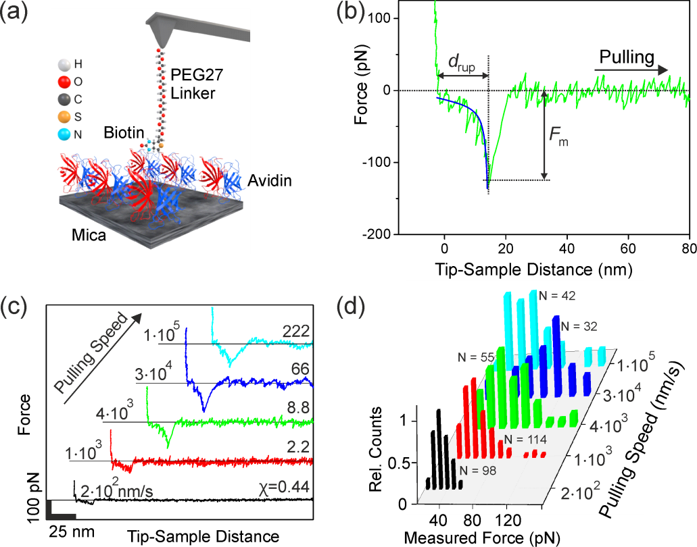

Figure 1. (a). Scheme of the tip’s functionalization and sample structure in an AFM-based SMFS experiment on biotin-avidin. The AFM cantilever is functionalized with a PEG27 linker. A single biotin is attached at the end of the linker (see Supplementary). A monolayer of avidin molecules is deposited on a mica surface. (b) The force-distance curve is acquired by pulling the tip away from the avidin monolayer. The fit obtained by applying the freely jointed chain model (FJC) is shown. (c) Force-distance curves acquired at different pulling speeds. F_{m} increases with the pulling speed until a certain threshold is reached. From then on the value of the measured force decreases with the pulling speed. The frequency ratio χ is also plotted. (d) Force histograms of biotin-avidin bonds reveal a maximum in the mean value of the F_{m} as a function of the loading rate. The panel depicts the number of specific unbinding events N used to build the histograms. Data: k=0.029 N/m, k_{PEG27}=0.0098 N/m, f₀=3.05 kHz, Q=1.6, f_{p}=0.5-203 Hz, A_{p}=250 nm.

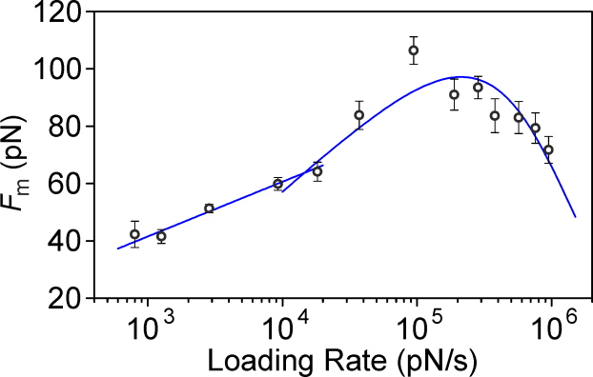

Figure 2. The mean value of the measured force is shown with respect to the logarithm of the loading rate. The solid lines show three different slopes. The first two (from low to high loading rates) are related to thermal activation transitions of different bound states (see Fig. 4). The last slope is negative. It indicates non-thermal forces dominate the measured force. SMFS data: k=0.029 N/m, k_{PEG27}=0.0098 N/m, f₀=3.05 kHz, Q=1.6, f_{p}=0.5-203 Hz, A_{p}=250 nm.

Figure 3. Simulations of the ligand-receptor bond strength spectrum. (a) Force dependence on the loading rate obtained by solving eqn (2) for cantilevers with f₀=10 kHz (black squares) and with f₀=100 kHz (blue triangles). By increasing the resonant frequency of the cantilever, the deviation between F_{m} and F_{rup} is reduced at high rates. (b) Ratio between the measured and the rupture force as a function of the frequency ratio χ for both cantilevers. The inset shows the relative error for several ranges of frequency ratios. (c) Comparison between the rupture force and the corrected rupture force for the cantilever characterized by f₀=10 kHz after using the correction factor N(r). Simulation parameters: f₀=10 kHz (black squares), f₀=100 kHz (blue triangles), k = 0.02 N/m, x_{u}=0.138 nm, k_{off} =12.2 s⁻¹, A_{p}=250 nm, Q = 1.

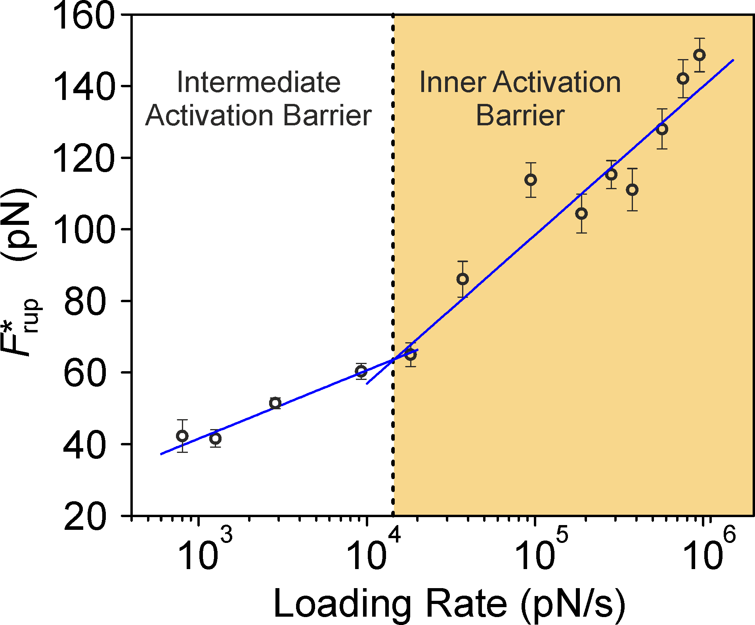
Figure 4. Corrected mean rupture force values (uncorrected data from Fig. 2) after the application of the factor N(r). The resulting forces follow the Bell-Evans model. The data shows two different bond transitions. The intermediate activation barrier is fitted by using the Bell-Evans model with x_{u}=0.5±0.06 nm and k_{off} =0.8±0.54 s⁻¹. The inner activation barrier parameters are obtained by correcting the data with the correction factor and, by fitting them to the Bell-Evans model (x_{u}=0.226±0.053 nm and k_{off} =23.6±19.9 s⁻¹).

