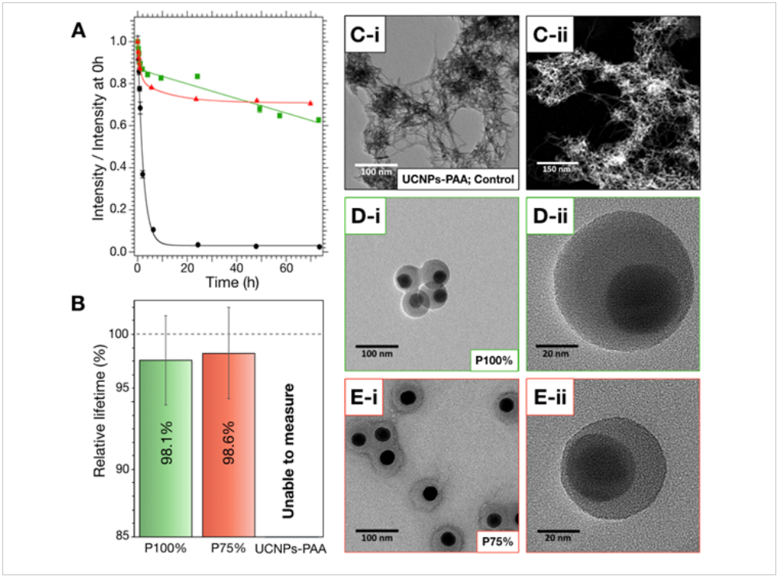

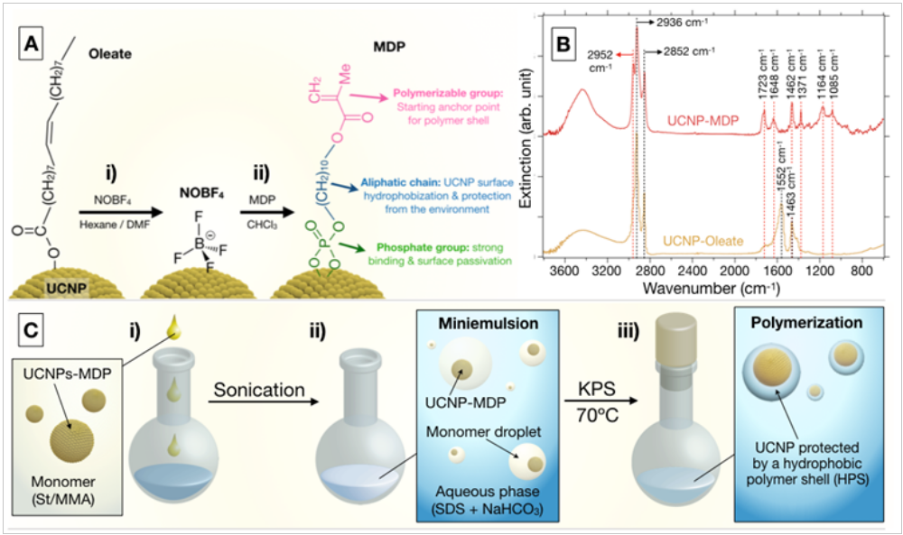

we present a
simple and rationale design of the UCNPs’ surface that ensures
their protection in aqueous media under different harsh conditions.
Our approach is based on the combination of two
synergic strategies: first, the oleic acid ligands at the surface
of UCNPs are replaced in nonpolar solvents by 10-methacryloyldecylphosphate
(MDP), to achieve surface passivation, colloidal
stability in organic media, and a terminal polymerizable
group. Second, the dispersion and free-radical miniemulsion
polymerization of these UCNPs in styrene (St), or a mixture
of St and methyl methacrylate (MMA), pursues the formation
of a robust hydrophobic shell of controlled thickness that insulates
and protects UCNPs from aqueous environment. This
method is also expected to provide them with colloidal stability
in aqueous media due to the presence of polar groups incorporated
during the polymerization process.

The stunning optical properties of upconverting nanoparticles (UCNPs) have
inspired promising biomedical technologies. Nevertheless, their transfer to
aqueous media is often accompanied by intense luminescence quenching,
partial dissolution by water, and even complete degradation by molecules such
as phosphates. Currently, these are major issues hampering the translation
of UCNPs to the clinic. In this work, a strategy is developed to coat and
protect β-NaYF4 UCNPs against these effects, by growing a hydrophobic
polymer shell (HPS) through miniemulsion polymerization of styrene (St), or
St and methyl methacrylate mixtures. This allows one to obtain single core@
shell UCNPs@HPS with a final diameter of ≈60–70 nm. Stability studies
reveal that these HPSs serve as a very effective barrier, impeding polar
molecules to affect UCNPs optical properties. Even more, it allows UCNPs
to withstand aggressive conditions such as high dilutions (5 μg mL−1), high
phosphate concentrations (100 mm), and high temperatures (70 °C). The
physicochemical characterizations prove the potential of HPSs to overcome
the current limitations of UCNPs. This strategy, which can be applied to other
nanomaterials with similar limitations, paves the way toward more stable and
reliable UCNPs with applications in life sciences.

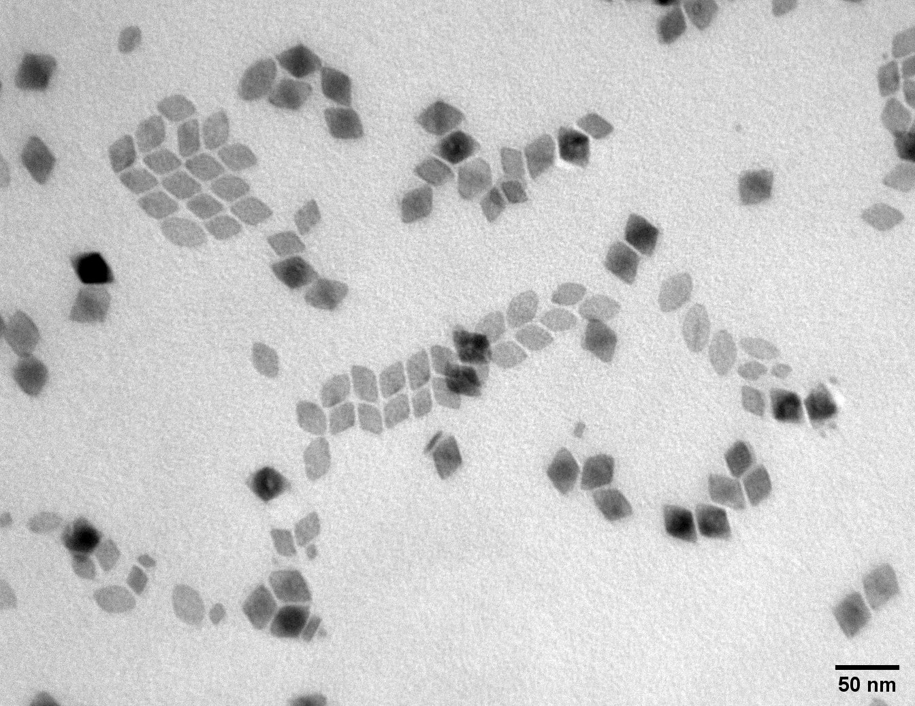

LiYF4:20Yb2Er@LiYF4

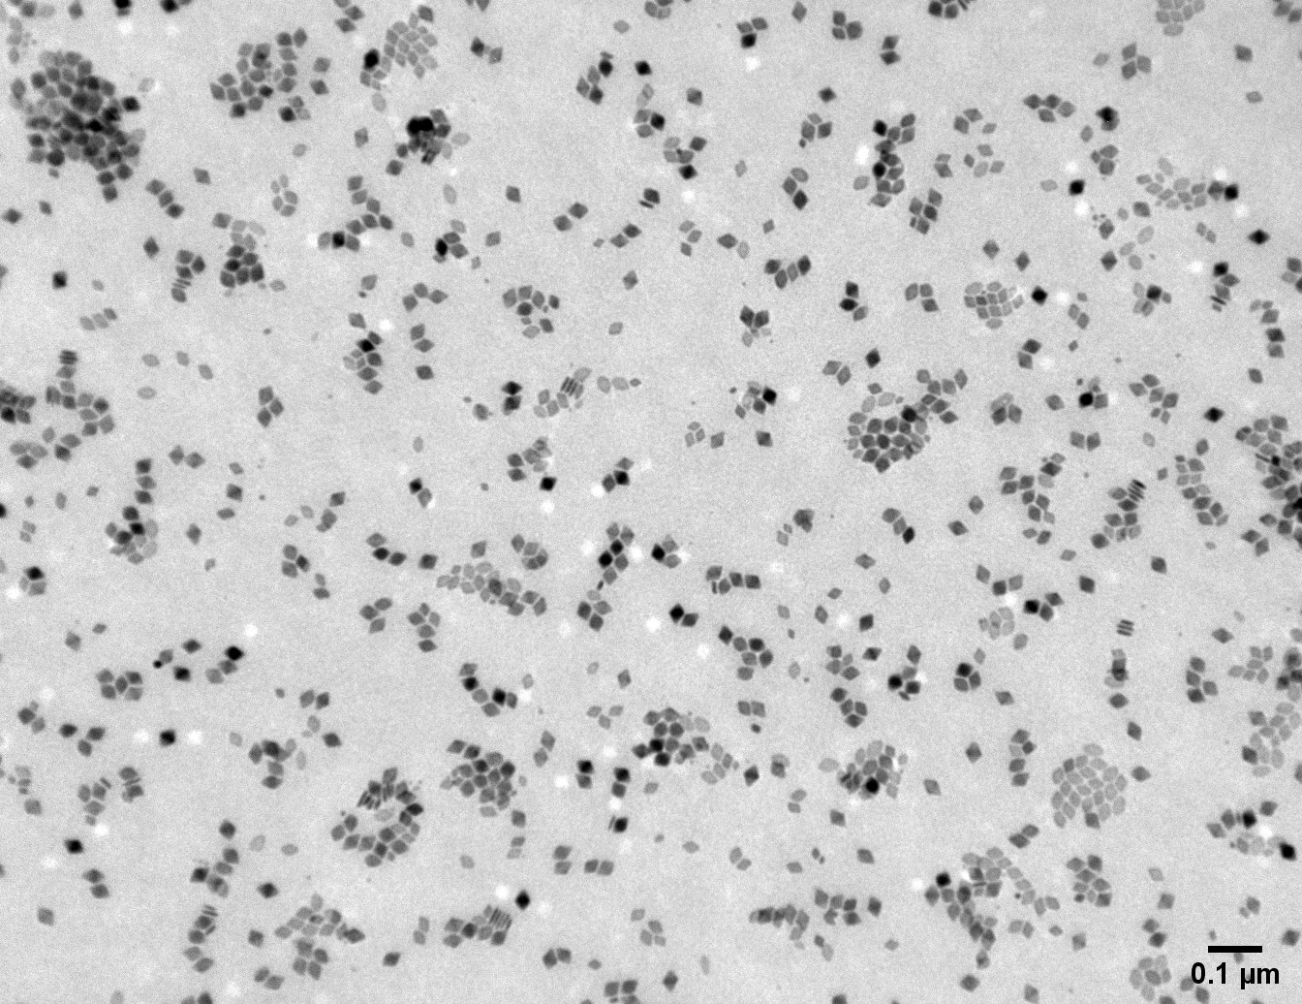

L

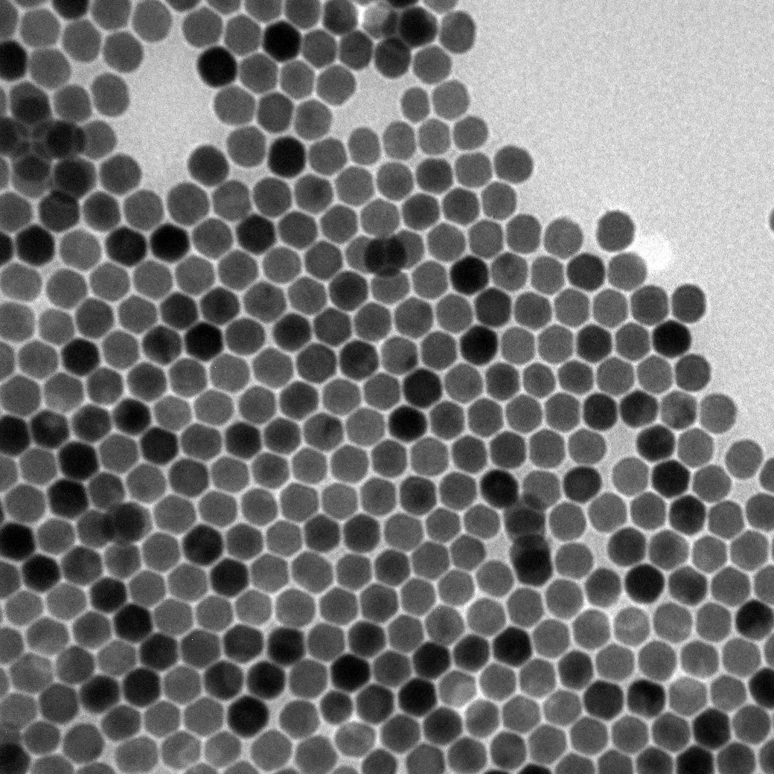

NaYF4:20Yb2Er

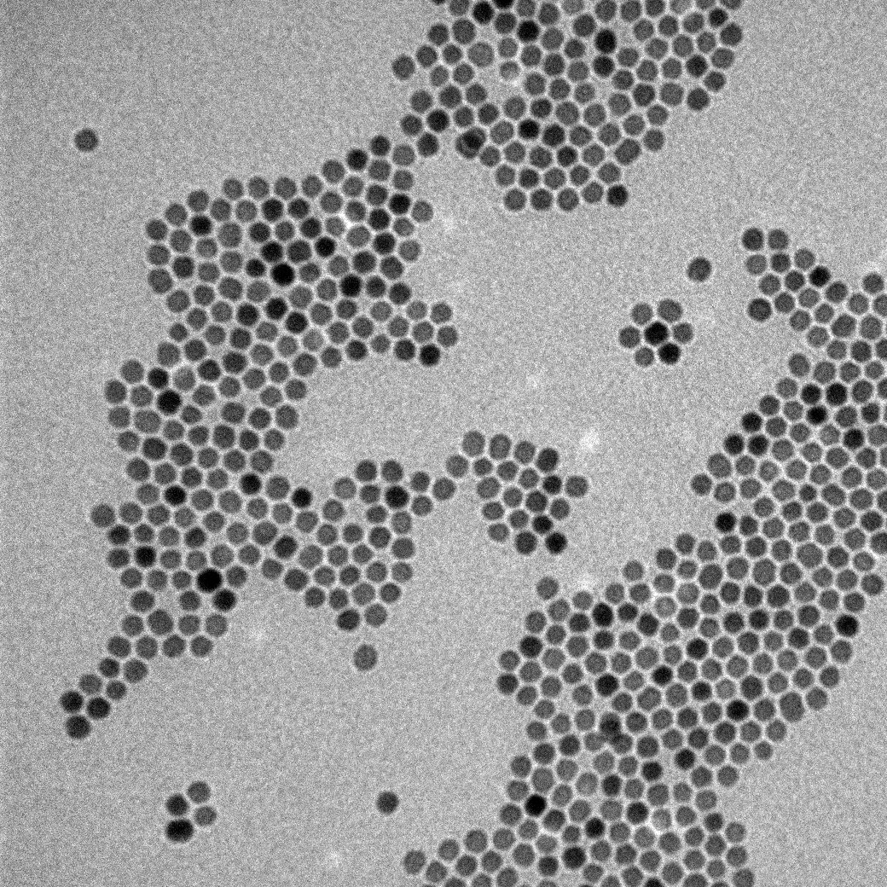

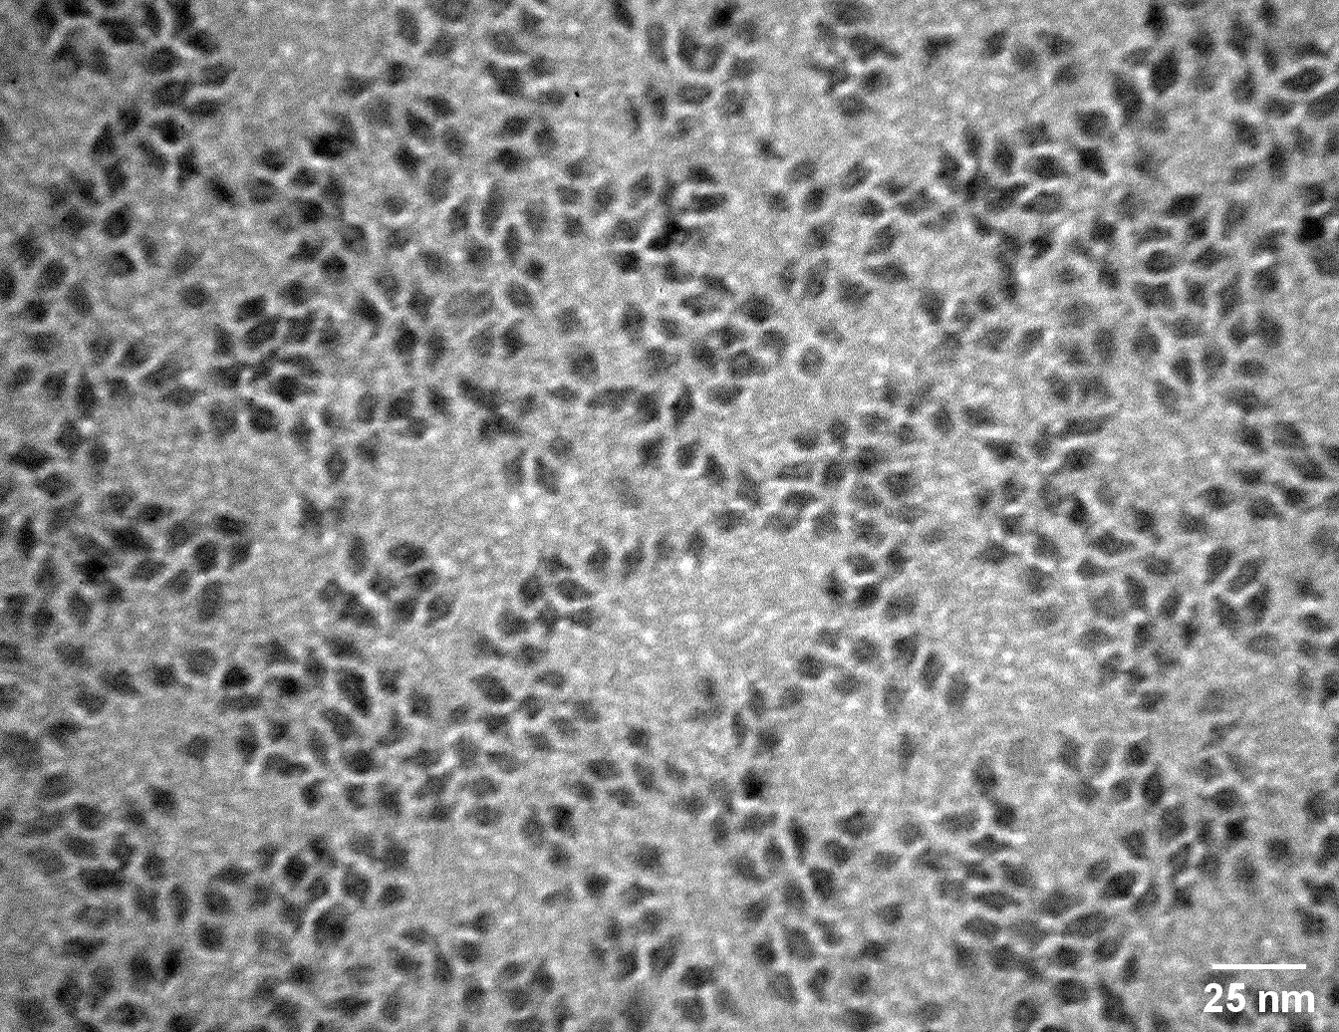

NaHoW@NaGdW:20Yb1Tm
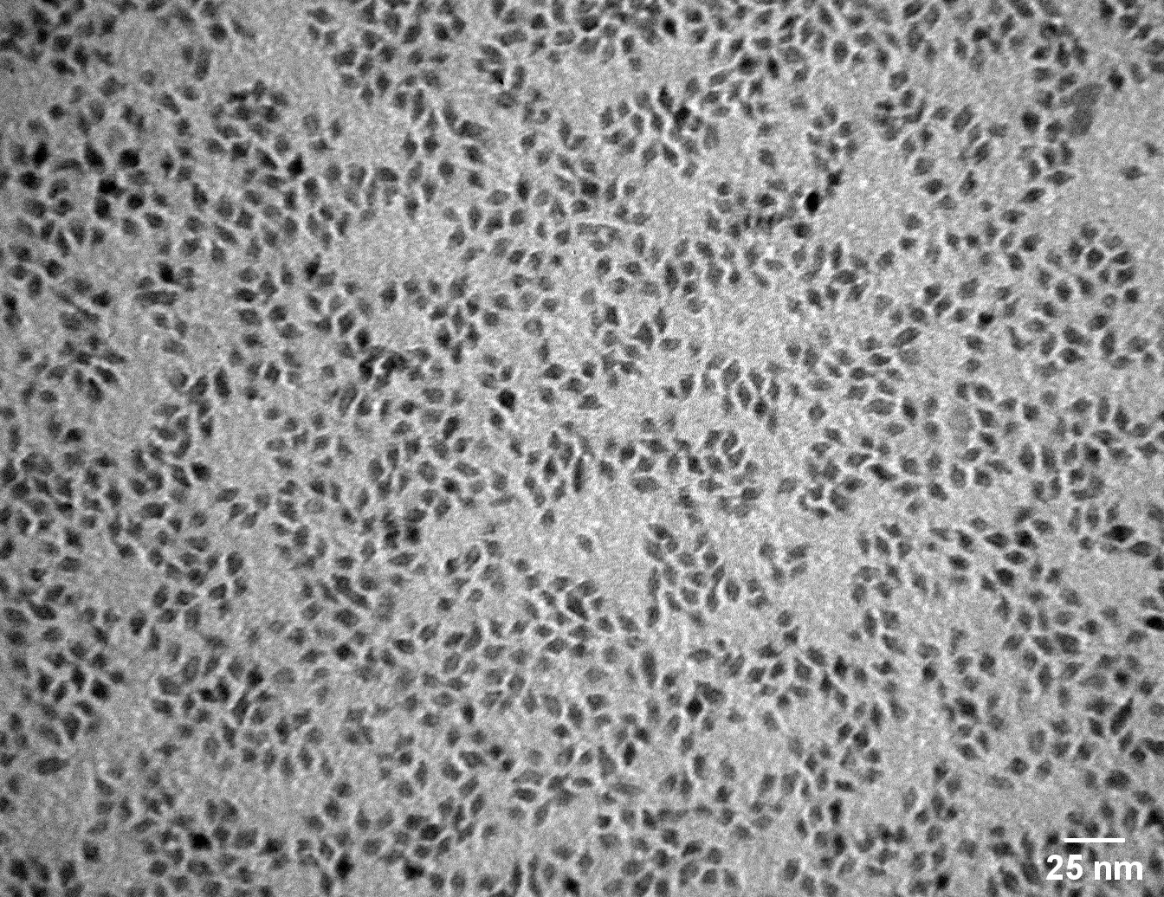

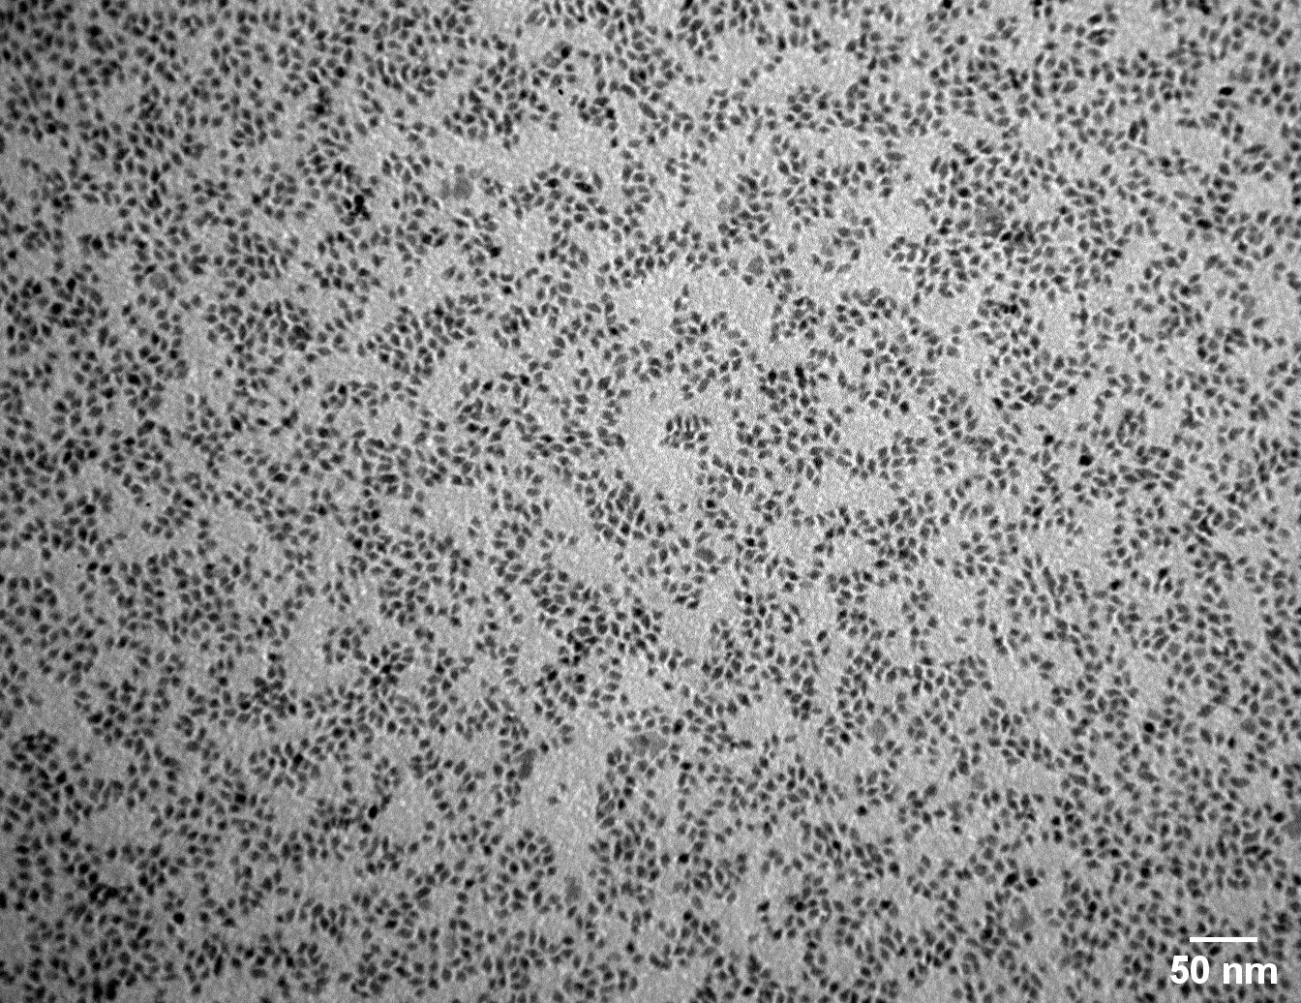

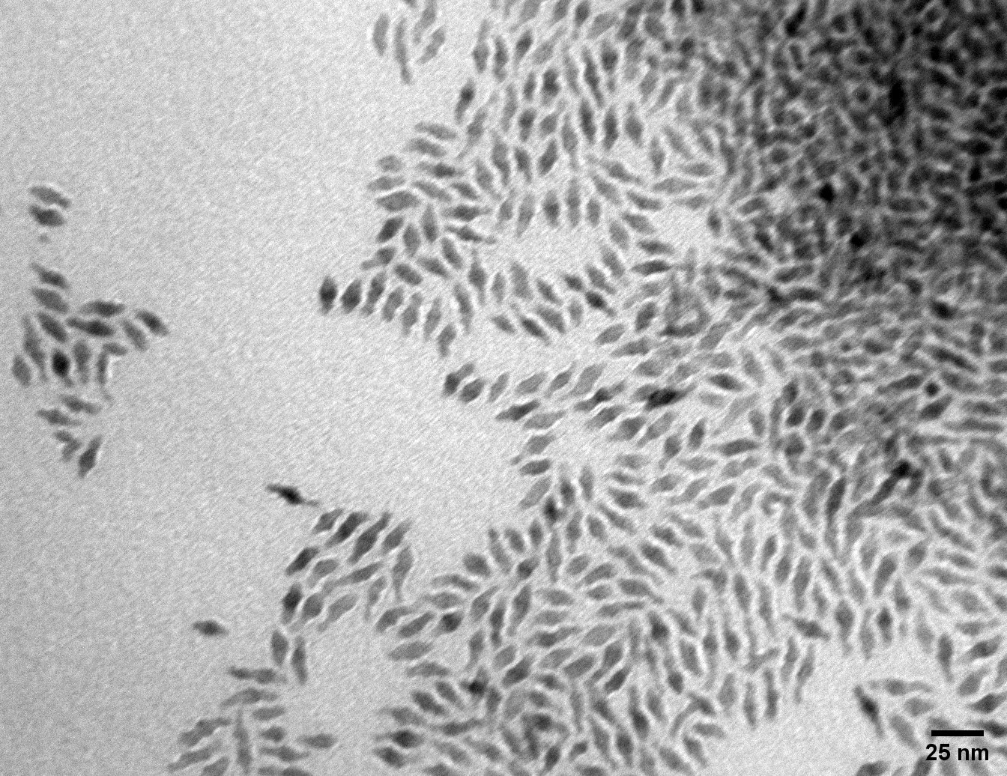

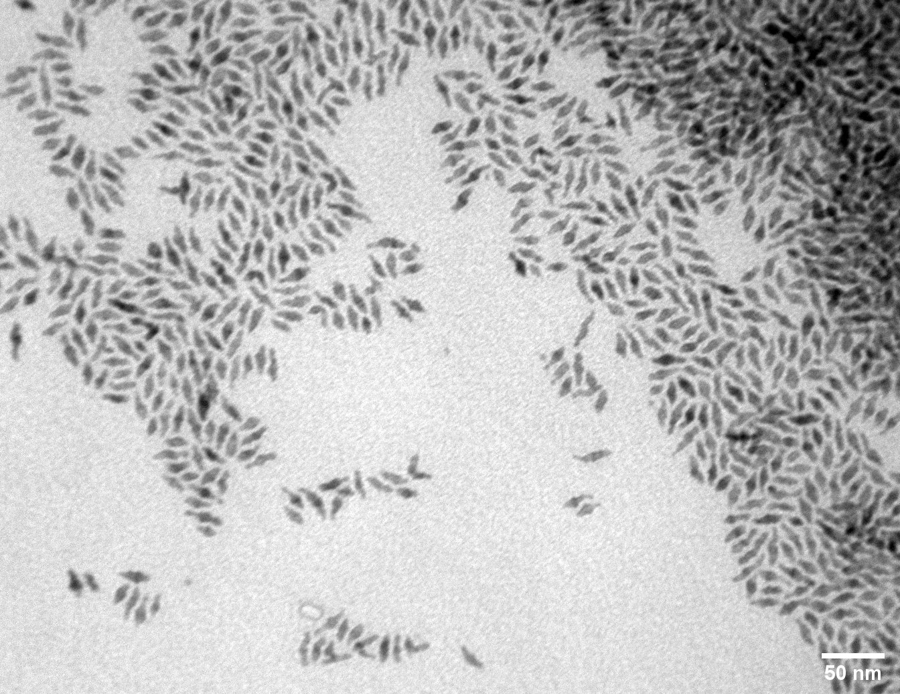

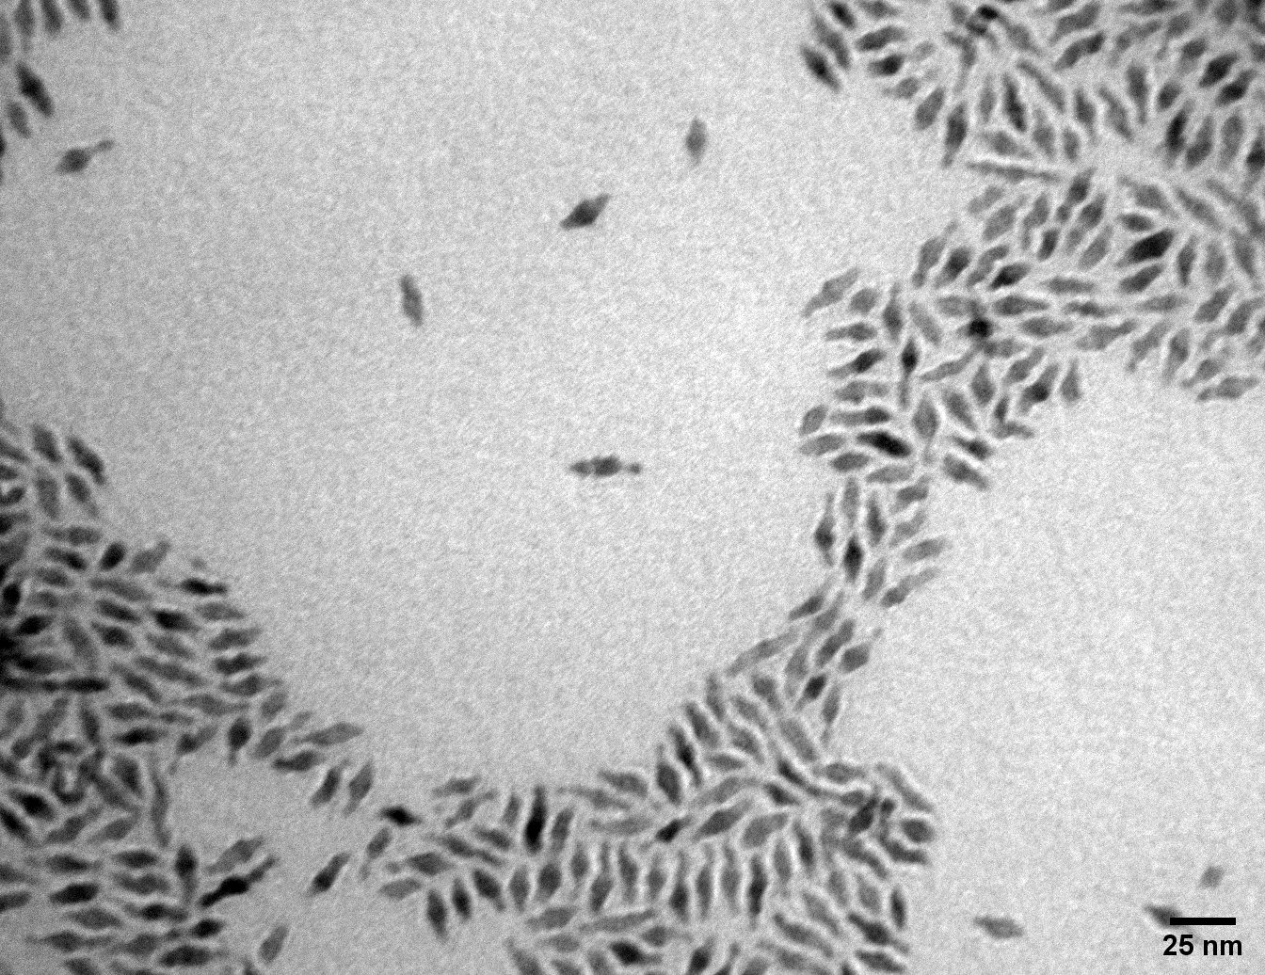

NaHoW@NaGdW;20Yb:1Tm@NaGdW:20Yb:20Nd

