Contratos para la realización de Tesis doctorales en Nanociencia y Nanomedicina

Area or Group of research:
Advanced force microscopy and nanolithography, Instituto de Ciencia de Materiales de Madrid (CSIC)

Description of Group/Project:

We offer several graduate student positions for developing advance force microscopy methods. We are seeking applicants who are interested in the study of soft matter-liquid interfaces and mechanical properties at the nanoscale. The aim of the offered positions is both the development of theoretical methods and the experimental application. The successful applicant will join the research group of Ricardo Garcia. An international team made by young, vibrant and knowledgeable scientists that work in an environment with frequent interactions with physicists, chemists and biologists (http://www.icmm.csic.es/forcetool/).

Qualifications, Experience and Skills Required:
Degree in Physics or related area. Candidates with experience in AFM operation will be positively evaluated. Good knowledge of English is required.

How to apply:
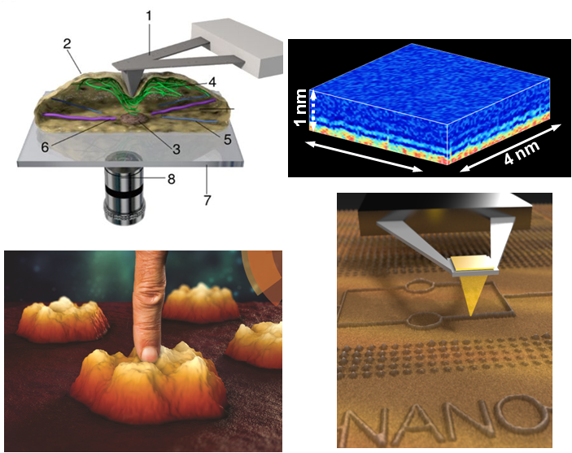
Interested candidates please send a CV along with a brief letter of motivation (150 words) to Ricardo Garcia, Instituto de Ciencia de Materiales de Madrid, CSIC, Spain (alma.perez@csic.es).

